

Project Title: Conference Assist Web Application

(By SEMESTER-V of III Year M.sc (CA & IT) 2020-21)

Submitted By:

Student Name: Roll. No:

Yash Nayak 3025

Panchal Pinkal 3030

Yash Prajapati 3057

Group ID: 16

Name of Company: K.S School of Business Management

Date of submission: 05/01/2020

Submitted To

K S School of Business Management

MSC. – Computer Applications and Information Technology



Certificate from Company:







**Acknowledgement**

The success and final outcome of this project required a lot of guidance and assistance from many people and we are extremely fortunate to have got this all for our project work. Whatever we have done is only due to such guidance and assistance and we would not forget to thank them.

We respect and thankful to K.S.S.B.M., for giving us an opportunity to do the project work and providing us all support and guidance which made us completes the project on time. We are extremely grateful to project guide for providing such a nice support and guidance though he had busy schedule.

We would like to express our gratitude towards Course co-ordinator Department and our project mentor for their kind co-operation and encouragement, which helped us in this project.

Group ID: 16

Yash Nayak (3025)

Pinkal Panchal (3030)

Yash Prajapati (3057)

**LIST OF FIGURES**

|  |  |  |
| --- | --- | --- |
| SR. No | FIGURE NAME | PAGE NO |
| 1 | Use Case Diagram | 23 |
| 2 | Activity Diagram | 27 |
| 3 | Class Diagram | 31 |
| 4 | Sequence Diagram | 32 |
| 5 | System Flow | 36 |

**LIST OF TABLES**

|  |  |  |
| --- | --- | --- |
| SR.NO | TABLE NAME | PAGE NO |
| 1 | User | 39 |
| 2 | Admin | 40 |
| 3 | Researcher | 41 |
| 4 | Reviewer | 42 |
| 5 | Participant | 43 |
| 6 | Abstract | 44 |
| 7 | Full Paper | 45 |
| 8 | Notice | 46 |
| 9 | Conference | 47 |
| 10 | Registration | 48 |

**TABLE OF CONTENTS**

|  |  |  |
| --- | --- | --- |
| CHAPTER | TITLE | PAGE NUMBER |
| 1 | INTRODUCTION | 8 |
|  | 1.1 ORGANIZATION PROFILE | 8 |
|  | 1.2 SYSTEM DETAILS | 9 |
|  | 1.2.1 CURRENT SYSTEM | 9 |
|  | 1.2.2 PROPOSED SYSTEM | 9 |
|  | 1.3 SCOPE | 10 |
|  | 1.4 OBJECTIVE | 11 |
| 2 | REQUIREMENT GATHERING | 12 |
|  | 2.1 STACKHOLDER | 12 |
|  | 2.2 REQUIREMENT GATHERING TECHNIQUE USED | 12 |
|  | 2.3 CONSILATED LIST OF REQUIREMENT | 15 |
|  | 2.4 PROJECT DERINATION | 16 |
| 3 | SYSTEM MANAGEMENT AND PLANNIG | 17 |
|  | 3.1 FEASIBILITY STUDY | 17 |
|  | 3.1.1 TECHNICALSTUDY | 17 |
|  | 3.1.2 ECONOMICAL STUDY | 18 |
|  | 3.1.3 OPERATIONAL STUDY | 18 |
|  | 3.2 HARDWARE-SOFTWARE REQUIREMENT | 19 |
|  | 3.3 SYSTEM PLANNING | 20 |
|  | 3.3.1 WORK BREAKDOWN STRUCTURE | 20 |
|  | 3.3.2 GANTT CHART | 21 |
|  | 3.4 PROCESS MODEL | 22 |
| 4 | SYSTEM ANALYSIS AND DESIGN | 23 |
|  | 4.1 UML(UNIFIED MODELING LANGUAGE) | 23 |
|  | 4.2 SYSTEM FLOW DIAGRAM | 36 |
|  | 4.3 DATA DICTIONARY | 39 |
|  | 4.4 USER INTERFACE | 49 |
|  | 4.5 SYSTEM NAVIGATION | 56 |
| 5 | SUMMARY | 65 |

Chapter: 1

Introduction

1.1 Organization Profile

Name: K.S. School of Business Management

Address: Gujrat University Campus, Navrangpura, Ahmedabad, Gujrat 380009.

Contact: 079 26305972

Email: [ksschool31@yahoo.co.in](mailto:ksschool31@yahoo.co.in)

**About:**

K. S. School of Business Management is one of the pioneer institutes offering Integrated MBA and MSc (Computer Applications & Information Technology) in India. Established under the aegis of Gujarat University, KSSBM started with five year integrated programme in MBA in 1993, followed by five year integrated programme in MSc (CA&IT) in 1998. Both the programmes have grown in size and stature, attracting Gujarat state´s young budding students after their 12th standard from all walks of life.

1.2 System Details

Conference Assist System is about the managing the conference procedures and formalities regarding to the organization member, reviewer, researcher, as well as participants. In this system, the administrator will be the service provider itself, who is responsible for all the conferences being provided to the organization.

1.2.1 Existing System

There are number of conference management system exist in the market but scope of the system is just encapsulated for the particular conference only which includes just couple of features.

On other hand there are some other applications which also provides the limited core features of the specific management of conferences. Some of the application also have some drawbacks regarding the privacy as well as the according to the protocols also.

E.g. [www.easychair.com](http://www.easychair.com) etc.

1.2.2 Proposed System

The Proposed System solves many problems of the Existing system by providing enormous features which can help the current system in terms of money, time and reputation. There are some important features given below that we will involve in the current system to make it more efficient and easy to use:

* Management and monitoring of the program committee
* Theme of the conference and its track for management and Information Technology
* Preparation of conference proceedings
* Registration
* Monitoring Email
* Discussion of Paper
* Abstract Submission
* Full Paper Submission
* Review Abstract
* Review Full Paper
* Notice & Circulars
* Maintenance of Records

Listed features will be moderated by the specific organization representative or organization committee members.

1.3 Scope of the System

The desired web application is designed to cover up the basic necessity of the particular organization based on their own requirement.

There are so many ways and situations where implementation of this web-app can be very useful. The scope of this system is wider than whatever stated above. Because implementation of this project will create a link to the members as well as the committee members and the duration of the solving problem regarding to the organization will be reduced because of the easy access service.

In addition, the researcher is also part of this system. Even, researcher plays the major role to participate in conference, send abstract papers and send full papers into the system.

In addition, the reviewer is also part of this system. Even, reviewer plays the major role to participate in conference, review abstracts and review full papers also, approve or disapprove abstract or full papers in the system.

In addition, the participant is also part of this system. Even, participant plays the major role to participate in conference and give feedback in the system.

To implement this system user just require any device which comes with the normal web browser. People will get much closer by interacting with this system to the other members.

1.4 Objectives

1) Digitalization:

The admin does not have to depend on multiple staff members for every single report. The communication process has been completely transformed as admin, researcher, reviewer and participant can easily circulate important information via mail alert service. Lesser need for paper and manual labour, means lesser aggregate costs of the academic institute.

2) Automation:

The automation feature of this conference management system will mitigate the task of writing the papers. E.g. there is no need to write the report card of the students on the paper by the pen. It is simply can be done online on the system, and can be forwarded to the students and their parents.

E.g. there is no need to send information regarding conference to individuals through email, or no need to collect abstracts or full papers hard copy to send it for review or approve it.

3) To provide a platform for easy interaction:

In today’s fast life, it is difficult to get connected with each researcher, participants and reviewer.

Because of this conference management system, it will easier for organization, researcher, reviewer and participant to be in touch with each other every day.

4) No Redundant Data:

As this conference management system will be centralized, the chances of the duplicate data in the system are close. In the existing system of the organization the chances of data redundancy are more as the records are saved in registers and not in computers so the number of errors can be more.

5) Maintenance of Records:

One of the prominent tasks to be done by the organization authorities and staff is to maintain records of each transaction. This also means keeping a track of all the activities starting from arrange conference till the approval. Relying on conference management software helps a lot as it makes things quite easier and saves on a lot of time. You don't have to flip pages in register to find the required data.

CHAPTER: 2

PROPOSED SYSTEM REQUIREMENT GATHERING

2.1 Stack holders of the system

There are mainly 4 types of the stack-holders who will be the backbone of this system.

* Conference Committee members
* Researcher
* Reviewer
* Participants

2.2 Requirement Gathering Technique Used

There are many techniques available for gathering the requirements. Each technique has value in certain scenario. Most of the time, it becomes necessary for Business Analyst to use some technique to gather complete and correct requirements from clients and stakeholders.

There are following techniques used for gathering requirements.

1) Surveys

2) Interview

3) Questionnaires

4) Brainstorming

5) Prototyping

6) Observation

We choose Questionnaires technique.

We have prepared a list of questions.

**Questions Asked to the Admin:**

Q1 - Why do you want to computerize the system?

A - Because in existing system process is offline and manual so it becomes very long and tedious. In proposed system entire recruitment process will be online. So it will be very easy and time saving for both company as well as candidate.

Q2 - What were problem in current system?

A – As said above in existing system for conference management is manually done. Researcher and participants have to go physically for attending conference. Abstract and Full Paper submission and review done manually so the process becomes long and tedious for organization, researcher, reviewer as well as participants.

Q3 - What type of functionality do you want in your proposed system?

A - The proposed system must be computerize in which user can access the system from anywhere. In the proposed system all the process for managing conference will be online. The researcher will submit abstract, full paper through system. Reviewer can view abstract and full paper and give their review for approve or disapprove the abstract or full paper. Participant can register them self and pay fees through online payment also they can attend the conference and give feedback.

Q4 - Which are the track you need to add in conference?

A – We select track according to MBA and MSC IT for example: Finance & accounting, HR, IT etc.

Q5 - How you send the detail of conference?

Email B) Social Media C) SMS D) Website Notice

Q6 - How do you collect abstract and full paper from researcher?

A – E Mail.

Q7 - How do you choose reviewer?

A - According to their specialization in subjects.

Q8 - How do you send abstract and full paper to the reviewer?

A - E Mail.

Q9 - How do you approve and disapprove abstract and full paper?

A - According to the reviews of reviewer.

Q10 - How do you send the information of approval or disapproval of abstract and full paper to the author?

A - Through Mail.

Q11 - How do author register in conference?

E mail B) Google form C) Offline D) Other

Q12 - How do you send registration conformation?

E mail B) SMS

Q13 - How do you send the information of payment conformation?

E mail B) SMS C) Receipt

Q14 - Which method you use for payment in your system?

Offline B) online(google pay, paytm, phone pay, card)

Q15 – How do you conduct the conference?

A - Offline.

**Questions Asked to the Researcher:**

Q1 - How you get the information about conference?

1. Through mail B) SMS C) Social Media D) Website

Q2 - How do you register for the conference?

A) Through mail B) Google form C) Offline D) Other

Q3 - How do you pay the fees for registration?

1. Offline B) online (google pay, paytm, phone pay, card)

Q4 - How do you get the conformation of registration?

A) Through mail B) SMS

Q5 - How do you send the abstract and full paper?

A - Through Mail.

Q6 - How do you get the approval or disapproval for abstract or full paper?

A - Through Mail.

Q7 - What is your purpose to participate in conference?

1. For Present & Publish Your Research B)only Attend Conference

**Questions Asked to the Reviewer:**

Q1 - Are you a reviewer or panellist?

A) Reviewer B) Panellist C) A & B Both

Q2 - How do you get the abstract and full paper for review?

A - Through Mail.

Q3 - How do you send the abstract and full paper reviews?

A - Through Mail.

**Questions Asked to the Participants:**

Q1 - How do you get information about conference?

A) Through mail B) SMS C) Social Media D) Website

Q2 - How do you register in conference?

A) Through mail B) Google form C) Offline

Q3 - How do you make payment?

A) Offline B) Online (google pay, paytm, phone pay, card)

Q4 - How do you get the payment conformation?

A) Through mail B) SMS C) Receipt

Q5 - How do you give the feedback?

A) Through mail B) Google form C) Offline

2.3 Consolidated List of Requirement

* Task for Admin
* Login
* Verify Profile Of Authors, Researchers And Reviewer
* Update Reviewer, Authors And Participants Profiles
* View All Transactions Of Registration
* Create Conferences
* Can Accept Abstracts From Authors/Researcher
* Can Send Abstracts To Reviewer For Review
* Can Get Reviews Of Abstract From Reviewer
* Can Approve And Disapprove Abstracts Of Authors/Researcher
* Can Accept Full Papers From Authors/Researcher
* Can Send Full Paper To Reviewer For Review
* Can Get Reviews Of Full Paper From Reviewer
* Can Approve And Disapprove Full Paper Of Authors/Researcher
* If There Is Any Changes Needed In Full Paper He/ She Can Return To Authors/Researcher
* Researcher/Author
* Login/Register
* Participate In Conference Through Online Fees Payment
* Submit Their Abstracts
* Submit Their Full Papers
* Get Notification Of Approval Or Disapproval Of Their Abstracts/Full Paper
* Reviewer
* Login
* Participate In Conference
* Accept Abstract From Admin For Review
* Send Review Of Abstract To The Admin
* Accept Full Paper From Admin For Review
* Send Review Of Full Paper To The Admin
* Participants
* Login/Register
* Participate In Conference Through Online Fees Payment
* Feedback

2.4 Project Definition

**Title: Conference Assist Web Application**

The Project Is About To manage Conference in which Program Committee can accept abstracts & full papers of research and can send it to Reviewer, Then Reviewer can send Review of abstracts & full papers. This Project Also Provide Registration through Online Fees payment.

CONFERENCE ASSIST Is A Conference Management System That Is Easy To Use, Flexible, And Has Many Features To Make Conference Organize In Easy Way. Conference Assist Manage and Monitor by the Program Committee.

CONFERENCE ASSIST is a Conference Management System That Provides,

* Organize Conference,
* Registration And Online Payment,
* Evaluating Project Proposals,
* List Of Events,
* Sending Email To Members, Researcher, and Reviewer,
* Monitoring Email,
* Abstract & Paper Submission,
* Reviewing Paper,
* Approve or Disapprove Paper.

CHAPTER: 3

SYSTEM MANAGEMENT AND PLANNIG

3.1 Feasibility Study:

Feasibility is the study of impact, which happens in the organization by the development of a system. The impact can be either positive or negative. When the positives nominate the negatives, then the system is considered feasible.

The main objective of the feasibility study is to test the Technical, Operational and Economical feasibility for adding new modules and debugging old running system. There are aspects in the feasibility study portion of the preliminary investigation:

* Technical Feasibility
* Operation Feasibility
* Economic Feasibility

3.1.1 Technical Feasibility:

* The technical feasibility study focuses on how you will deliver a product or service how you will deliver a product or service through which technology?
* There are number of features which are included into this system the main technologies and the tools which are connected with this system is :
* Python
* MySQL
* Django
* HTML / CSS
* It is a web based user interface. Thus it provides an easy access to the users.
* To access the system, internet connectivity is must require, because it is web Based websites.
* From these, it is clear that current system developed is technically feasible.

3.1.2 Economical Feasibility:

* Economic feasibility is based on cost and be benefits.
* The cost of hardware and software for the class of application being considered.
* The benefits in the form of reduced costs of fewer costly errors.
* The cost if nothing change (i.e. the proposed system is not developed).
* We are using the open source platform to build our system.
* Thus, the project is economically feasible for both client and us.

3.1.3 Operational feasibility:

* Operational feasibility states how the requirements are satisfied and also provides possible solutions.
* By doing so there is no need for the company either to recruit some special individual to run the system or spend a huge amount to train some individual.
* Thus, the project is operationally individual.
* This project well-planned design would ensure the optimal utilization of the resources and would help in the improvement of performance status.

3.2 Hardware – Software Requirement

**Hardware (Recommended)**

* Processor: Pentium Microprocessor and above
* Hard Disk: 40 GB or above
* RAM: 2 GB or More

**Software (Recommended)**

* Windows XP,7,8,8.1,10 or any higher versions of OS
* My SQL
* Any Web Browser
* Internet Connectivity

**Technology Used**

* + Frontend Technology:
    - HTML
    - CSS
    - JQUERY
    - Boot Strap
  + Frontend Tools:
    - Subline
    - Visual studio code
  + Backend Technology:
    - Python
  + Backend Framework:
    - Django

3.3 System Planning

3.3.1 Work Breakdown Structure

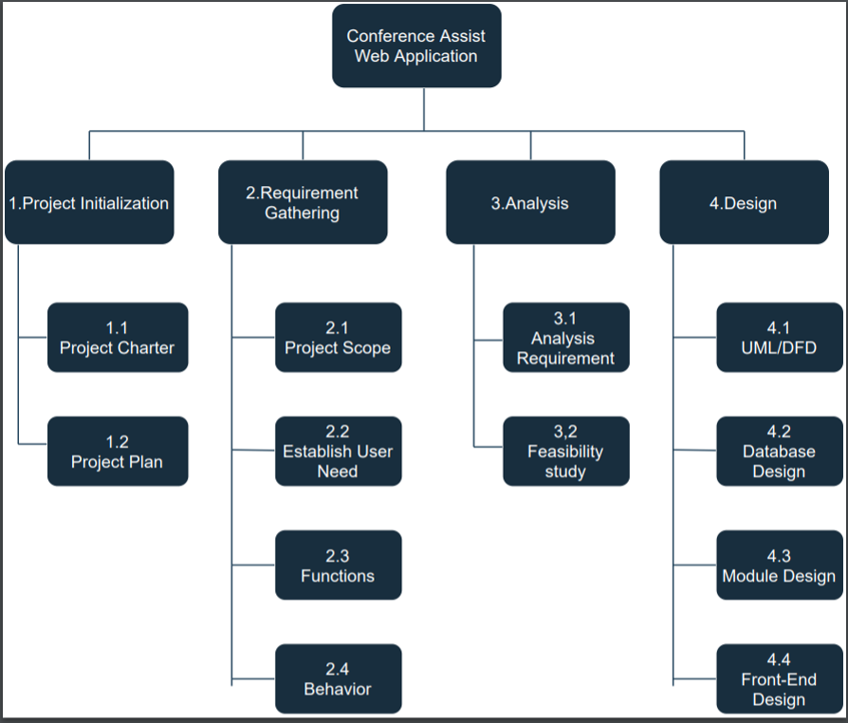

3.3.2 Gantt Chart

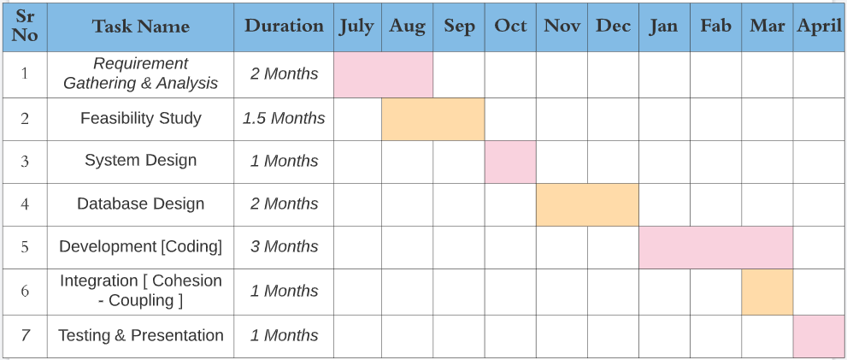

**2020-2021**

3.4 Process Model [Incremental Model]:

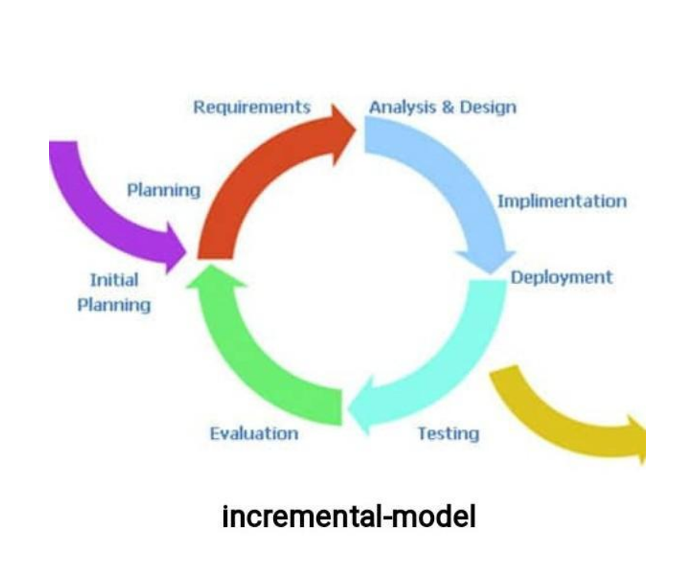

CHAPTER: 4

SYSTEM ANALYSIS AND DESIGN

4.1 UML (Unified Modelling Language)

1) Use Case Diagram:

Admin Use Case

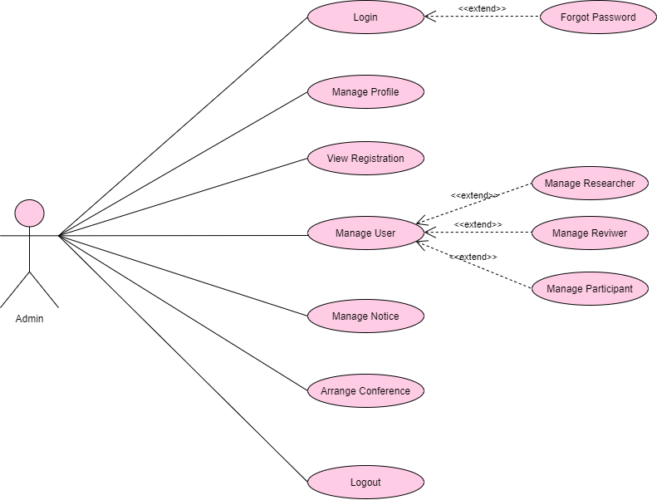

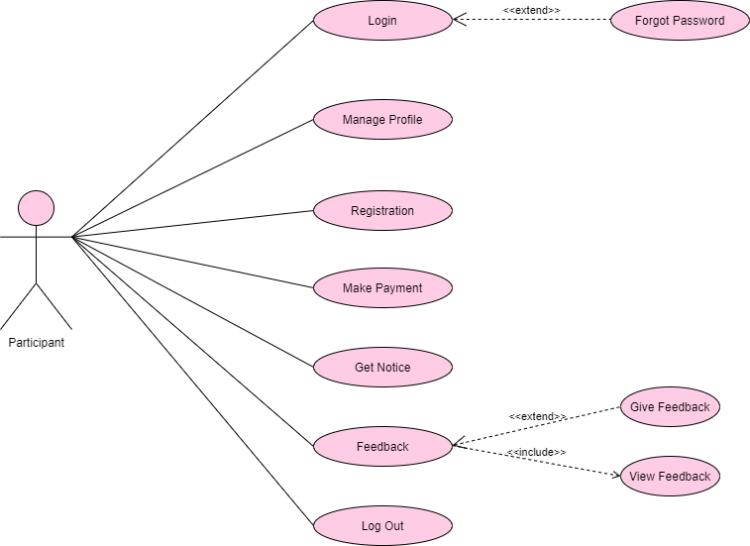

Participate Use Case

Reviewer Use Case

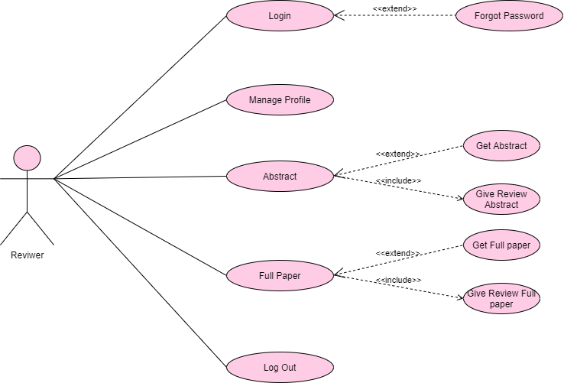

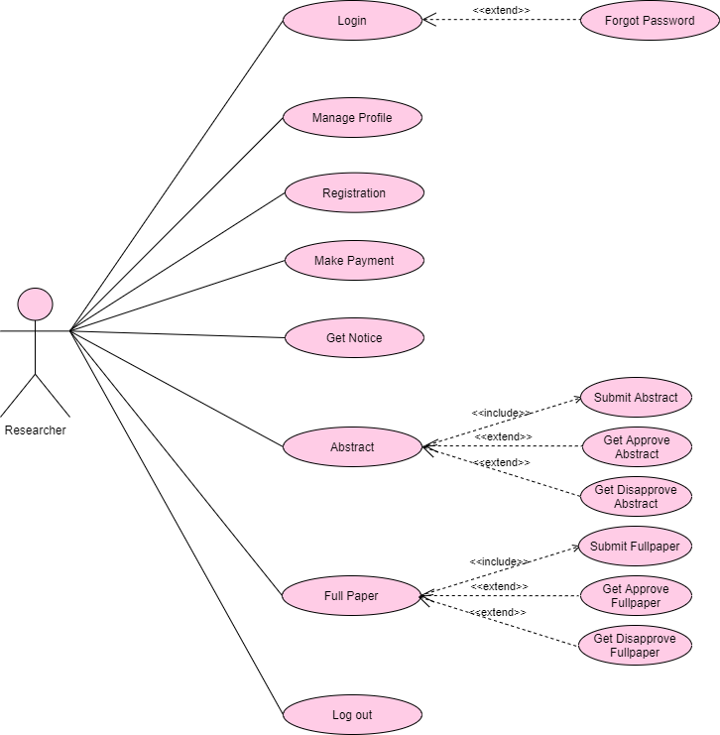

Researcher Use Case

2) Activity Diagram:

Admin Activity Diagram

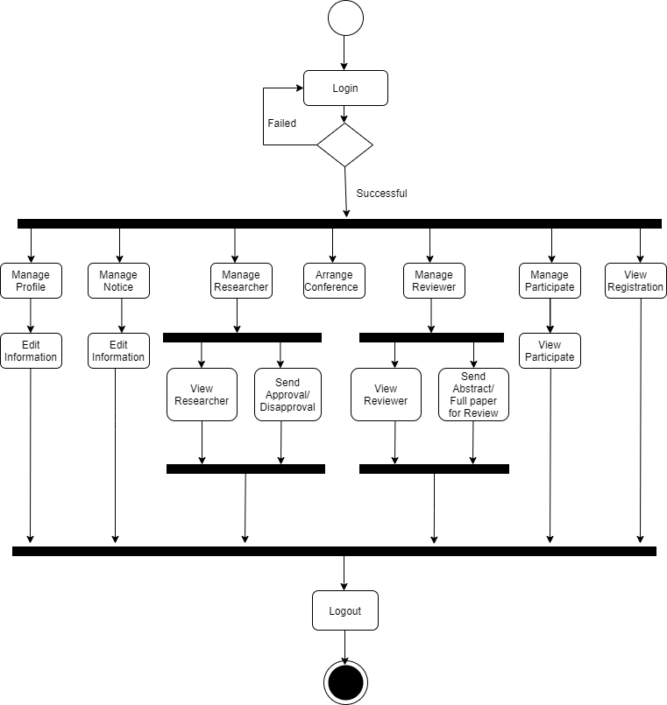

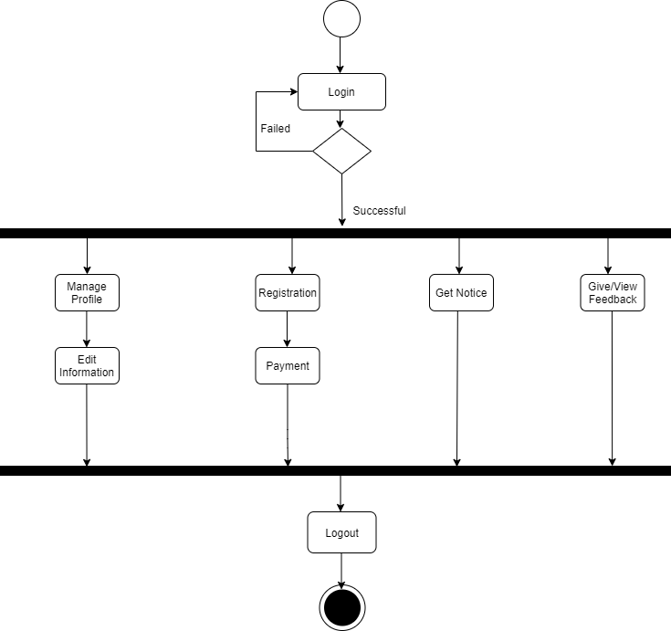

Participate Activity Diagram

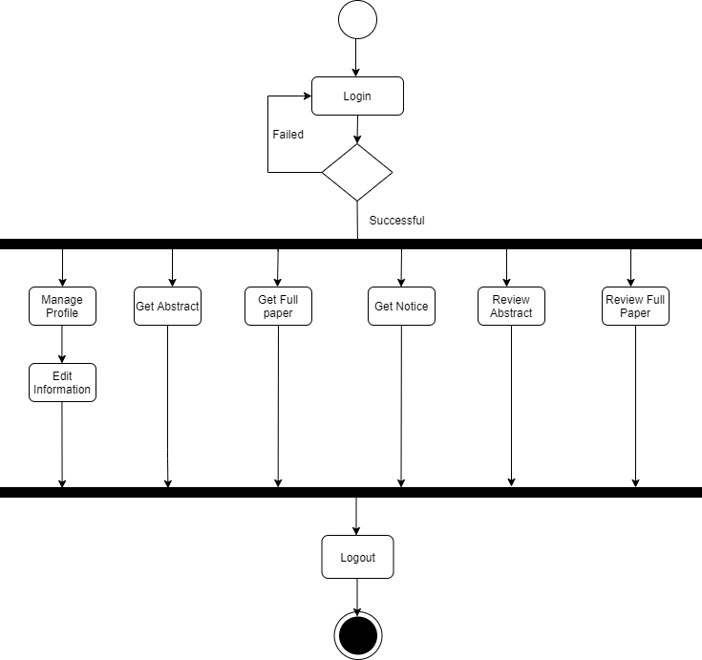

Reviewer Activity Diagram

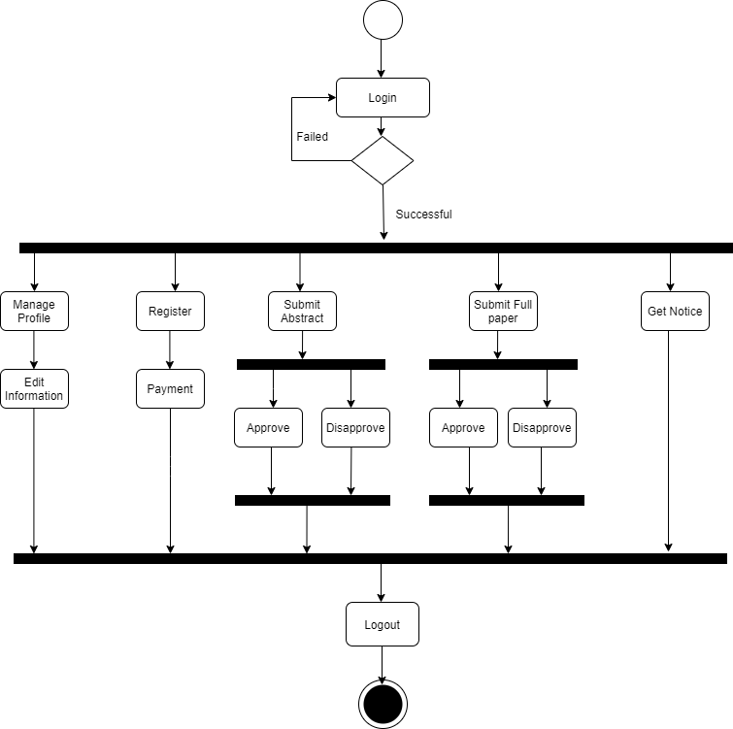

Researcher Activity Diagram

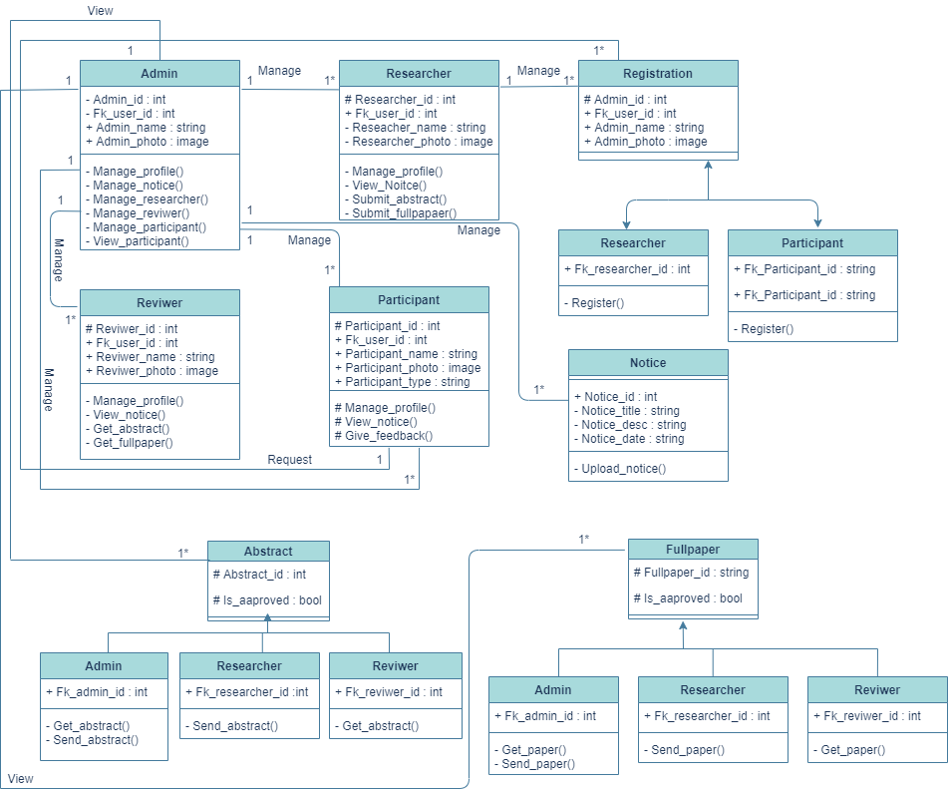3) Class Diagram:

Class Diagram

4) Sequence Diagram:

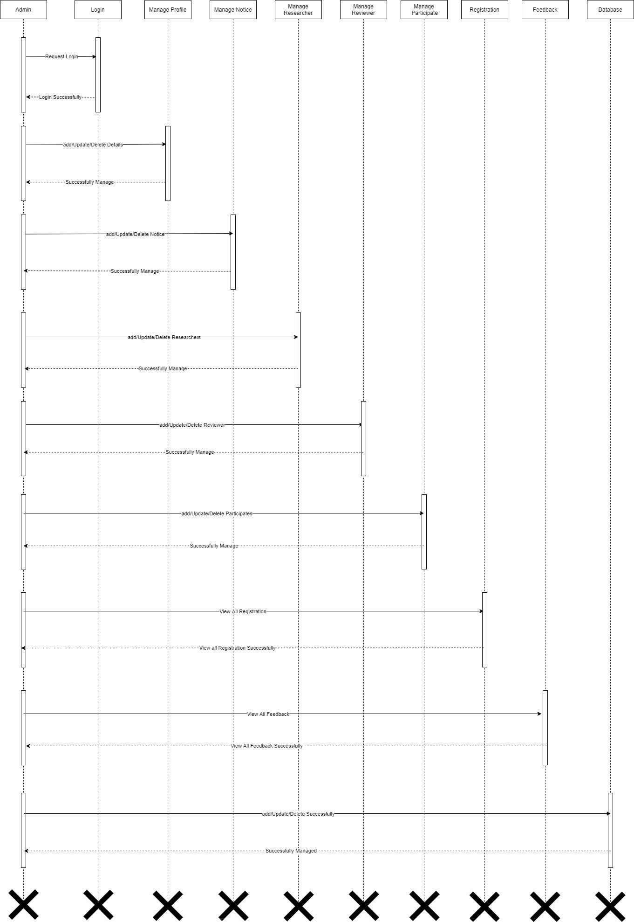

Admin Sequence Diagram

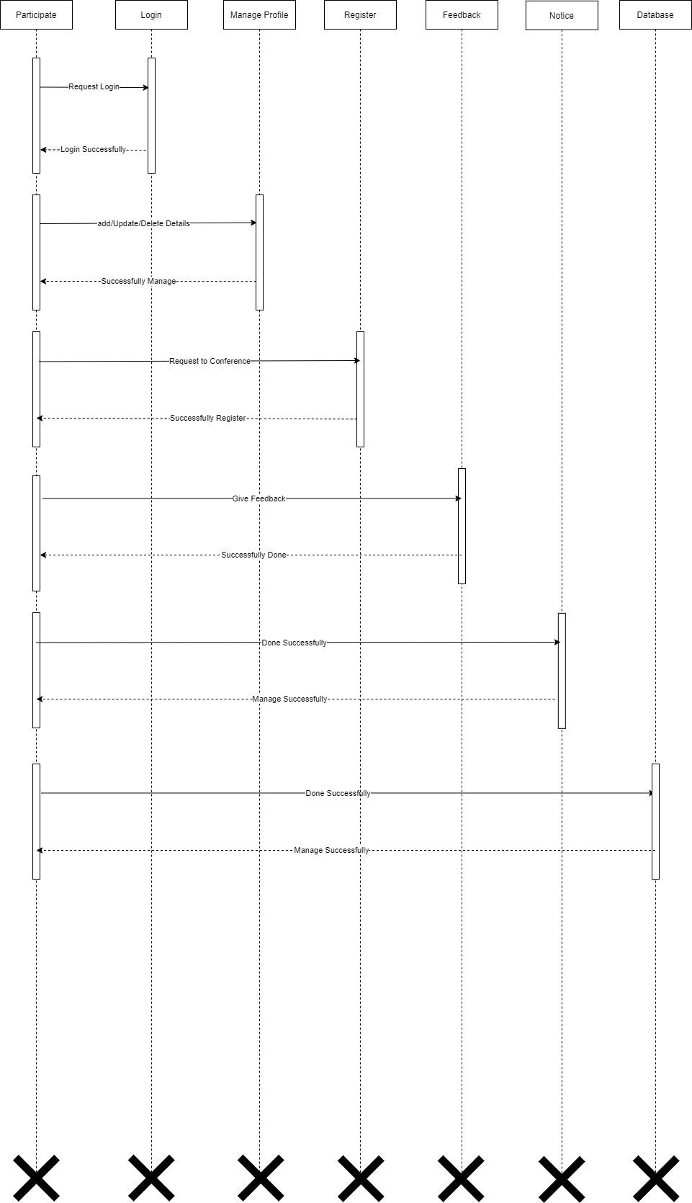

Participant Sequence Diagram

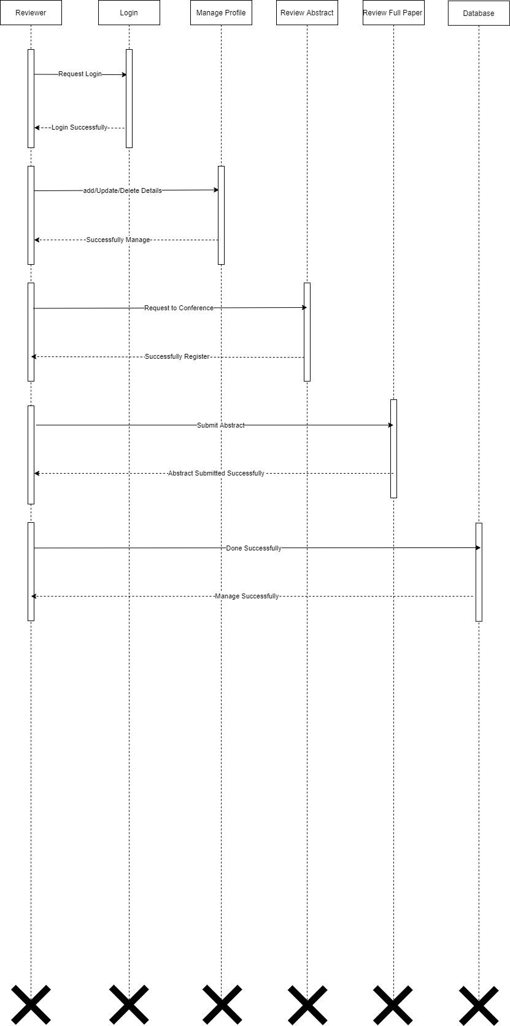

Reviewer Sequence Diagram

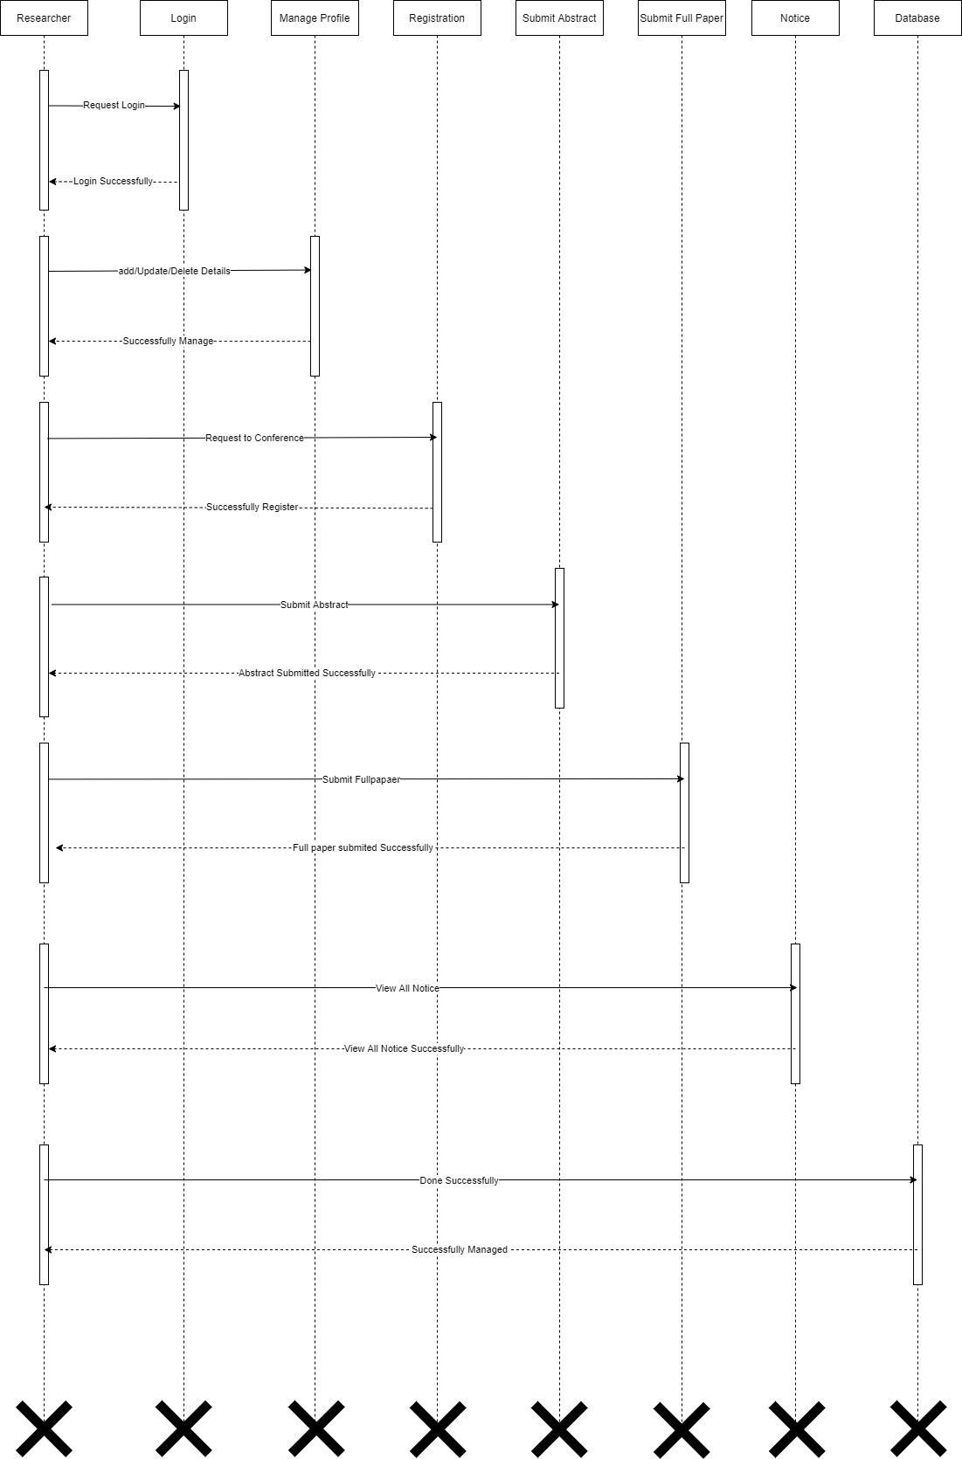

Researcher Sequence Diagram

4.2 System Flow Diagram: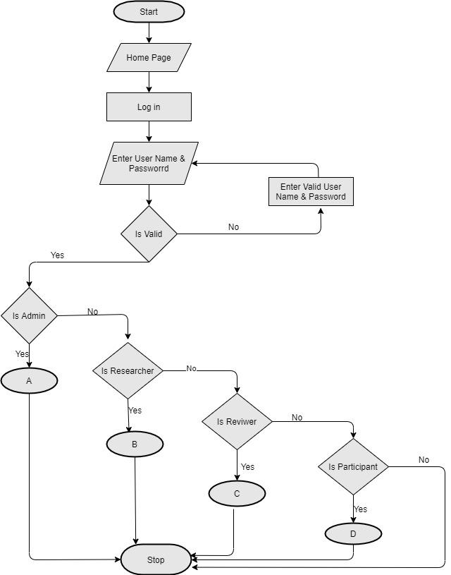

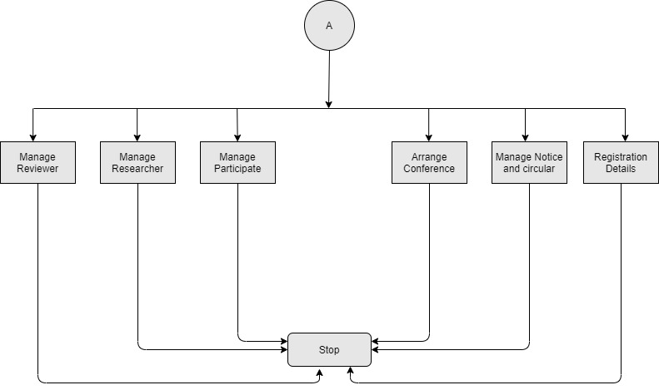

Researcher SFD

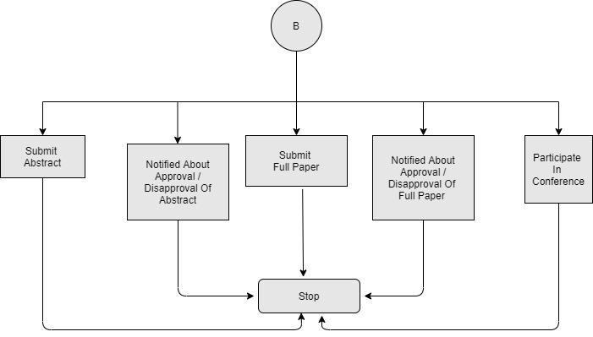

Admin SFD

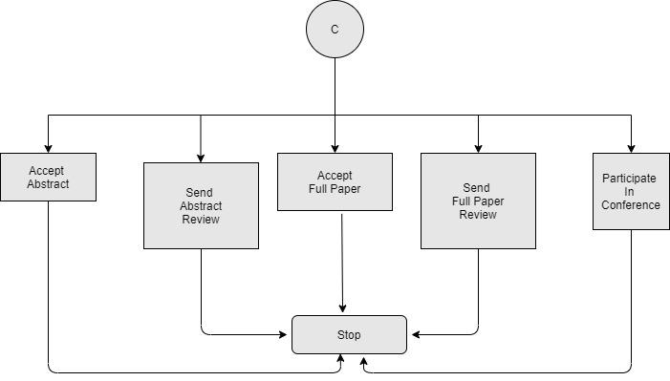

Reviewer SFD

Participant SFD

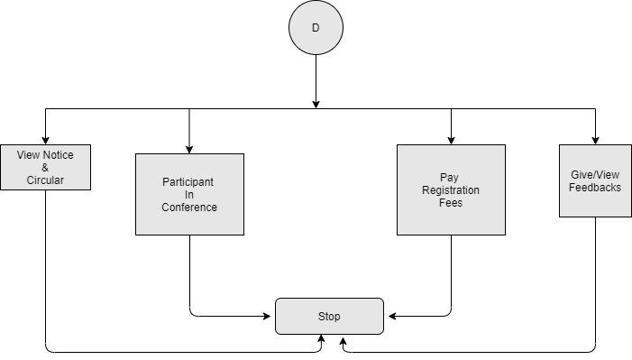

4.3 Data-Dictionary

Table-Name: user_tbl

Primary key: user_id

Description: Stores user data.

|  |  |  |  |  |  |
| --- | --- | --- | --- | --- | --- |
| No. | Field Name | Data Type | Size | Constraint | Description |
| 1 | User_id | Integer | 4 | Primary Key | It stores the user id. |
| 2 | Role | Varchar | 10 | Not Null | It stores the user role. |
| 3 | Firstname | Varchar | 50 | Not Null | It stores the user First Name. |
| 4 | Lastname | Varchar | 50 | Not Null | It stores the user Last Name |
| 5 | Email | Varchar | 25 | Not Null | It stores the user email. |
| 6 | Password | Varchar | 08 | Not Null | It stores the password. |
| 7 | Title | Varchar | 10 | Not Null | It stores user title |
| 8 | Is_verified | Boolean | - | Not Null | It is user for verification. |

Table-Name: admin_tbl

Primary key: admin_id

Description: Stores admin data.

|  |  |  |  |  |  |
| --- | --- | --- | --- | --- | --- |
| No. | Field Name | Data Type | Size | Constraint | Description |
| 1 | Admin_id | Integer | 4 | Primary Key | It stores the admin id. |
| 2 | Email | Varchar | 25 | Not Null | It stores the user id. |
| 3 | Phone | Integer | 10 | Not Null | It stores the phone number. |
| 4 | Password | Varchar | 08 | Not Null | It stores the Password. |

Table-Name: researcher_tbl

Primary key: researcher_id

Description: Stores researcher data.

|  |  |  |  |  |  |
| --- | --- | --- | --- | --- | --- |
| No. | Field Name | Data Type | Size | Constraint | Description |
| 1 | Researcher_id | Integer | 4 | Primary Key | It stores the researcher id |
| 2 | Res_user | Integer | 4 | Foreign Key | It stores the user id |
| 3 | Phone | Varchar | 10 | Not Null | It stores the phone number. |
| 4 | Photo | Image Path | - | Not Null | It stores the image path. |
| 5 | About | Varchar | 50 | Not Null | It stores the |
| 6 | Address | Varchar | 50 | Not Null | It stores the address |

Table-Name: reviewer_tbl

Primary key: reviewer_id

Description: Stores reviewer data.

|  |  |  |  |  |  |
| --- | --- | --- | --- | --- | --- |
| No. | Field Name | Data Type | Size | Constraint | Description |
| 1 | Reviewer_id | Integer | 4 | Primary Key | It stores the reviewer id |
| 2 | Reviewer_user | Integer | 4 | Foreign Key | It stores the user id |
| 3 | Phone | Varchar | 10 | Not Null | It stores the phone number. |
| 4 | Photo | Image Path | - | Not Null | It stores the image path. |
| 5 | About | Varchar | 50 | Not Null | It stores the |
| 6 | Address | Varchar | 50 | Not Null | It stores the address |

Table-Name: participant_tbl

Primary key: participant_id

Description: Stores participant data.

|  |  |  |  |  |  |
| --- | --- | --- | --- | --- | --- |
| No. | Field Name | Data Type | Size | Constraint | Description |
| 1 | Participant_id | Integer | 4 | Primary Key | It stores the Participant id |
| 2 | Parti_user | Integer | 4 | Foreign Key | It stores the user id |
| 3 | Phone | Varchar | 10 | Not Null | It stores the phone number. |
| 4 | Photo | Image Path | - | Not Null | It stores the image path. |
| 5 | About | Varchar | 50 | Not Null | It stores the |
| 6 | Address | Varchar | 50 | Not Null | It stores the address |

Table-Name: abstract_tbl

Primary key: abstract_id

Description: Stores abstract data.

|  |  |  |  |  |  |
| --- | --- | --- | --- | --- | --- |
| No. | Field Name | Data Type | Size | Constraint | Description |
| 1 | Abstract_id | Integer | 4 | Primary Key | It stores the abstract id. |
| 2 | Title | Varchar | 20 | Title | It stores the abstract title. |
| 3 | Description | Varchar | 50 | Not Null | It stores the description. |
| 4 | Date | Date Field | - | Not Null | It stores the date. |
| 5 | Abstract_file | Varchar | 100 | Not Null | It stores the path of file. |
| 6 | Status | Varchar | 10 | Not Null | It is store the status. |
| 7 | Paper_id | Integer | 4 | Not Null | It stores the paper id. |
| 8 | Fk_researcher_ id | Integer | 4 | Foreign Key | It stores the researcher id. |
| 9 | Fk_registration_id | Integer | 4 | Not Null | It stores the researcher registration id. |

Table-Name: full_paper_tbl

Primary key: fullpaper_id

Description: Stores full paper data.

|  |  |  |  |  |  |
| --- | --- | --- | --- | --- | --- |
| No. | Field Name | Data Type | Size | Constraint | Description |
| 1 | FullPaper_id | Integer | 4 | Primary Key | It stores the fullpaper id. |
| 2 | Title | Varchar | 20 | Title | It stores the abstract title. |
| 3 | Description | Varchar | 50 | Not Null | It stores the description. |
| 4 | Date | Date Field | - | Not Null | It stores the date. |
| 5 | FullPaper_file | Varchar | 100 | Not Null | It stores the path of file. |
| 6 | Status | Varchar | 10 | Not Null | It is store the status. |
| 7 | Paper_id | Integer | 4 | Not Null | It stores the paper id. |
| 8 | Fk_researcher_ id | Integer | 4 | Foreign Key | It stores the researcher id. |
| 9 | Fk_registration_id | Integer | 4 | Not Null | It stores the researcher registration id. |

Table-Name: notice_tbl

Primary key: notice_id

Description: Stores notice data.

|  |  |  |  |  |  |  |
| --- | --- | --- | --- | --- | --- | --- |
| No. | Field Name | Data Type | Size | | Constraint | Description |
| 1 | Notice_id | Integer | | 4 | Primary Key | It stores the notice id. |
| 2 | Title | Varchar | | 20 | Foreign Key | It stores the notice title. |
| 3 | Description | Varchar | | 50 | Not Null | It stores the description. |
| 4 | Date | Date Field | | - | Not Null | It stores the notice date. |
| 5 | File | FileField | | - | Not Null | It stores the path of file |

Table-Name: feedback_tbl

Primary key: feedback_id

Description: Stores feedback data

|  |  |  |  |  |  |
| --- | --- | --- | --- | --- | --- |
| No. | FieldName | Data Type | Size | Constraint | Description |
| 1 | Feedback_id | Integer | 4 | Primary Key | It stores the feedback id. |
| 2 | Feedback_user | Integer | 4 | Foreign Key | It stores the user id |
| 3 | Date | Date Filed | - | Not Null | It stores the feedback date |
| 4 | Theme | Varchar | 20 | Not Null | It stores the theme |
| 5 | Description | Varchar | 200 | Not Null | It stores the feedback description |

Table-Name: Registration Category

Primary Kay : RegCategory_id

Description :- Stores registration category data

|  |  |  |  |  |  |
| --- | --- | --- | --- | --- | --- |
| No. | FieldName | Data Type | Size | Constraint | Description |
| 1 | RegCategory_id | Integer | 4 | Primary Key | It stores the Registration category id. |
| 2 | Category | Varchar | 20 | Not Null | It stores the category id |
| 3 | Amount | Varchar | 20 | Not Null | It stores the Amount |

Table-Name: Participant Registrationx

Primary Key: Parti_reg_id

Description: Stores participant register data

|  |  |  |  |  |  |
| --- | --- | --- | --- | --- | --- |
| No. | FieldName | Data Type | Size | Constraint | Description |
| 1 | Parti_reg_id | Integer | 4 | Primary Key | It stores the participant registration id |
| 2 | Participant_id | Integer | 4 | Foreign Key | It stores the participant id |
| 3 | Date | Date Filed | - | Not Null | It stores participant registration date |
| 4 | Institue | Varchar | 50 | Not Null | It stores the institute name |
| 5 | Address | Varchar | 150 | Not Null | It stores the address |
| 6 | RegCategory | Integer | 4 | Foreign Key | It stores category id |
| 7 | Designation | Varchar | 50 | Not Null | It stores Designation |
| 8 | Amount | Integer | 4 | Not Null | It stores amount |
| 9 | Conference_  Theme_id | Integer | 4 | Foreign Key | It stores the conference them |
| 10 | Payment_status | Boolean | - | Not Null | It stores payment status |

Table-Name: Theme

Primary Key: Teme_id

Description: it stores the description data

|  |  |  |  |  |  |
| --- | --- | --- | --- | --- | --- |
| No. | FieldName | Data Type | Size | Constraint | Description |
| 1 | Theme_id | Integer | 4 | Primary Key | It stores the Theme id. |
| 2 | Theme_name | Varchar | 100 | Not Null | It stores the theme name |
| 3 | Sub_theme | ListTextField | - | Not Null | It stores the sub_theme |

Table-Name: conference_tbl

Primary key: Conf_id

Description: Stores conference data

|  |  |  |  |  |  |  |
| --- | --- | --- | --- | --- | --- | --- |
| No. | FieldName | Data Type | Size | Constraint | | Description |
| 1 | Conf_id | Integer | 4 | | Primary Key | It stores the Theme id. |
| 2. | Theme_id | Integer | 4 | | Foreign Key | It stores the conference them |
| 3 | Confe_mode | Varchar | 10 | | Not Null | It stores the conference mode |
| 4 | Date | Date Field | - | | Not Null | It stores the date of conference |
| 5 | Start_time | Time Field | - | | Not Null | It stores the starting time of conference |
| 6 | End_time | Time Field | - | | Not Null | It stores the ending time of conference |
| 7 | Palce | Varchar | 100 | | Not Null | It stores the place of the conference |
| 8 | Online_link | Varcher | 100 | | Not Null | It stores the link of the confernece |
| 9 | Abs_submission  _date | Date Field | - | | Not Null | It stores abstract submission date |
| 10 | Abs_acceptance  _date | Date Field | - | | Not Null | It stores abstract acceptance date |
| 11 | Full_paper_  submission_date | Date Field | - | | Not Null | It stores fullpaper submission date |
| 12 | Full_paper_  acceptance_date | Date Field | - | | Not Null | It stores fullpaper acceptance date |
| 13 | Description | Text Field | - | | Not Null | It stores conference description |

Table-Name: Review Abstract

Primary Key: Rev_abs_id

Description: It stores abstract reviews

|  |  |  |  |  |  |
| --- | --- | --- | --- | --- | --- |
| No. | Field Name | Data Type | Size | Constraint | Description |
| 1 | Rev_abs_id | Integer | 4 | Primary Key | It stores abstract reviews id |
| 2 | Date | Date Filed | - | Not Null | It stores abstract reviews date |
| 3 | Reviewer_id | Integer | 4 | Foreign Key | It stores the reviewer id |
| 4 | Evaluation | Varchar | 100 | Not Null | It stores abstract evaluation data of reviewer |
| 5 | Abstarct_id | Integer | 4 | Foreign Key | It stores abstract id |
| 6 | Reviews | Text Field | - | Not Null | It stores the abstract reviews of reviewer |

\

Table-Name: Review Fullpaper

Primary Key: Rev_fullpaper_id

Description: It stores abstract reviews

|  |  |  |  |  |  |
| --- | --- | --- | --- | --- | --- |
| No. | Field Name | Data Type | Size | Constraint | Description |
| 1 | Rev_fullpaper_id | Integer | 4 | Primary Key | It stores fullpaper reviews id |
| 2 | Date | Date Filed | - | Not Null | It stores fullpaper reviews date |
| 3 | Reviewer_id | Integer | 4 | Foreign Key | It stores the reviewer id |
| 4 | Evaluation | Varchar | 100 | Not Null | It stores fullpaper evaluation data of reviewer |
| 5 | Fullpaper_id | Integer | 4 | Foreign Key | It stores fullpaper id |
| 6 | Reviews | Text Field | - | Not Null | It stores the fullpaper reviews of reviewer |

Table-Name: researcher _registration_tbl

Primary key: Res_reg_id

Description: Stores researcher registration data

|  |  |  |  |  |  |
| --- | --- | --- | --- | --- | --- |
| No. | Field Name | Data Type | Size | Constraint | Description |
| 1 | Res_reg_id | Auto_field | 4 | Primary Key | It stores the researcher registration id |
| 2 | Date | Date Field | - | Not Null | It stores the date of researcher registration |
| 3 | Conference_id | Integer | 4 | Foreign Key | It stores the conference theme |
| 4 | Resarcher_id | Integer | 4 | Foreign Key | It stores the researcher id |
| 5 | Institute | Varchar | 50 | Not Null | It stores institute name |
| 6 | Address | Text Field | - | Not Null | It stores the address |
| 7 | Reg_category_id | Integer | 4 | Foreign Key | It stores category |
| 8 | Designation | Varchar | 50 | Not Null | It stores designation |
| 9 | Mambers | Varchar | 10 | Not Null | It stores total numbers of members |
| 10 | Co_authors | Varcher | 100 | Not Null | It stores co_author name |
| 11 | Total_amount | Integer | 5 | Not Null | It stores the amount |
| 12 | Payment_status | Boolean | - | Not Null | It stores payment status |

Table-Name: Co_author

Primary Key: Co_author_id

Description: It stores the co_author data

|  |  |  |  |  |  |
| --- | --- | --- | --- | --- | --- |
| No. | Field Name | Data Type | Size | Constraint | Description |
| 1 | Co_author_id | Integer | 4 | Primary Key | It stores co_author id |
| 2 | Res_reg_id | Integer | 4 | Foreign Key | It stores the researcher_registraion_id |
| 3 | Researcher_id | Integer | 4 | Foreign Key | It stores researcher name |
| 4 | Title | Varchar | 10 | Not Null | It stores co_auhtor title |
| 5 | Firstname | Varchar | 50 | Not Null | It stores co_author first name |
| 6 | Lastname | Varchar | 50 | Not Null | It stores co_author last name |
| 7 | Email | Varchar | 25 | Not Null | It stores co_author email |
| 8 | Phone | Big Integer Field | 15 | Not Null | It stores co_author phone number |
| 9 | Institute | Varchar | 50 | Not Null | It stores institute name |
| 10 | Address | Text Field | - | Not Null | It stores the address |
| 11 | Reg_category_id | Integer | 4 | Foreign Key | It stores category |
| 12 | Designation | Varcher | 50 | Not Null | It stores designation |

4.4 User Interface:

Home Page:

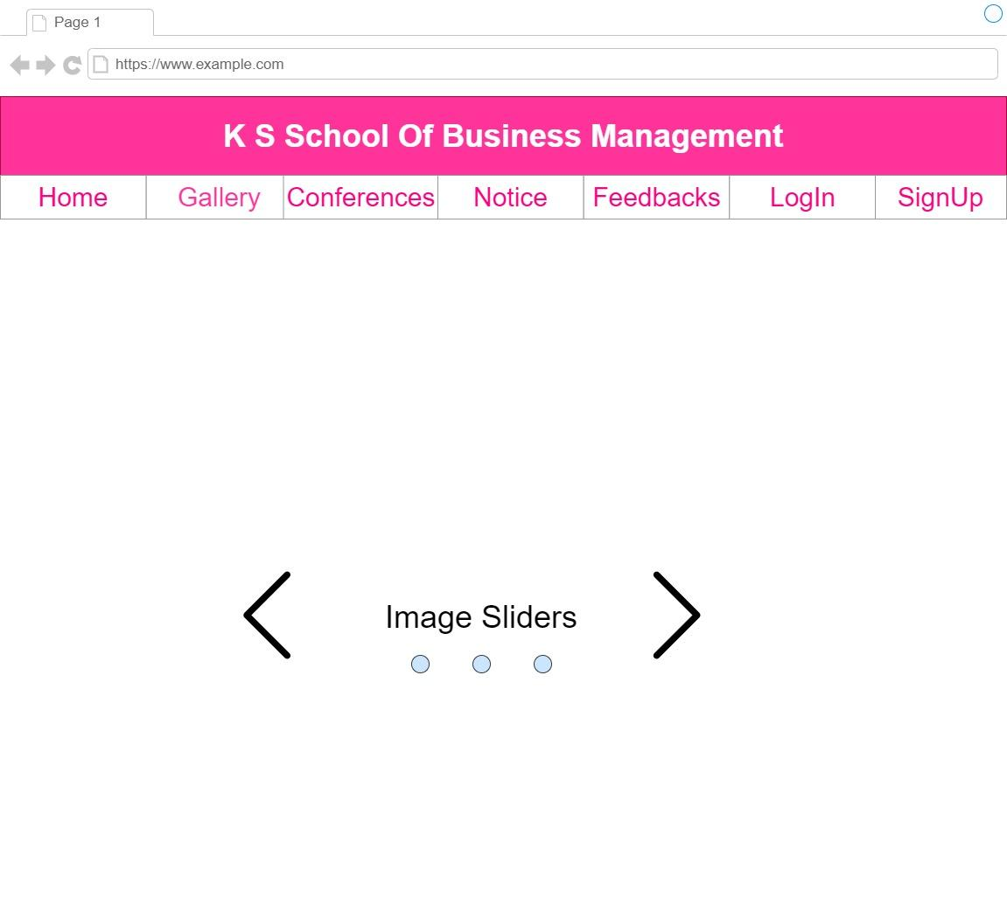

Description: This is the Home Page of the System.

Login Page: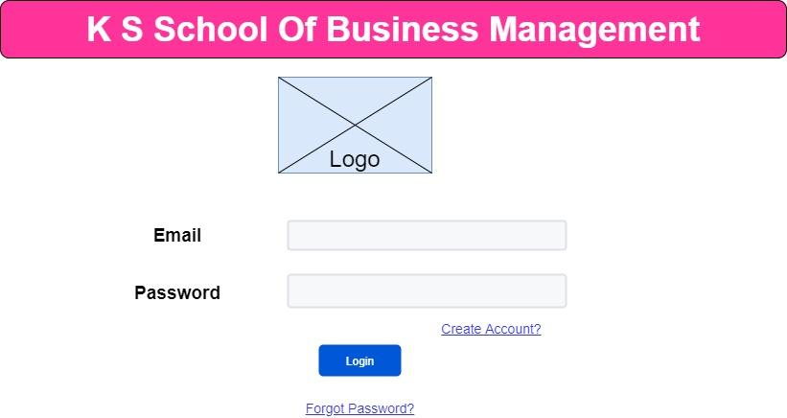

Description: This is the Login Page of the System.

Signup Page:

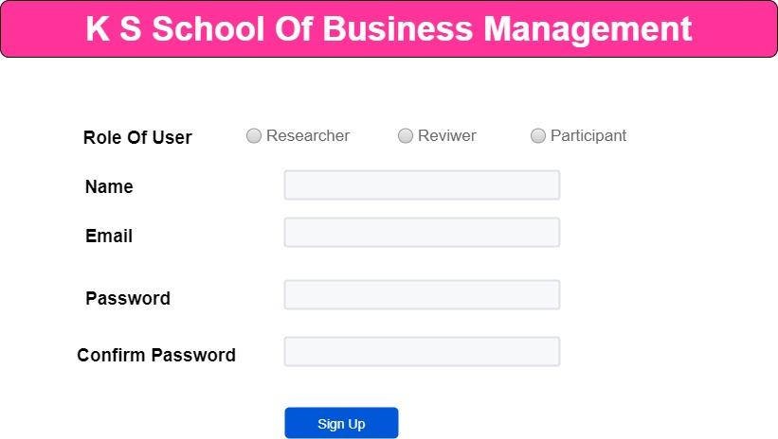

Description: This is the Signup page of the System.

Admin:

Dashboard: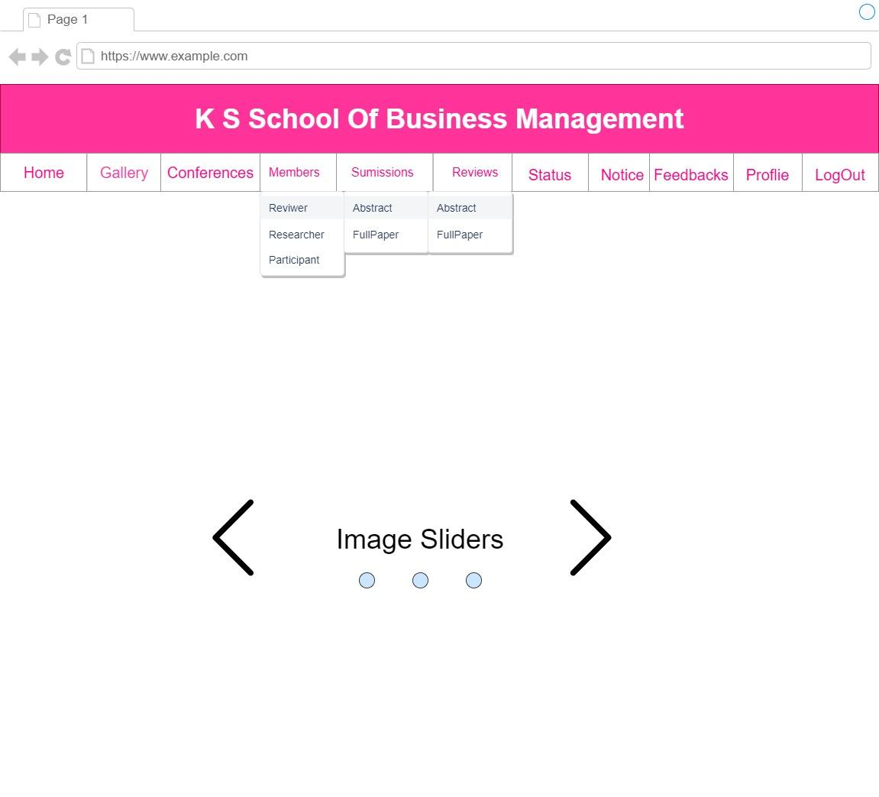

Description: Manage all the modules.

Edit Conferences: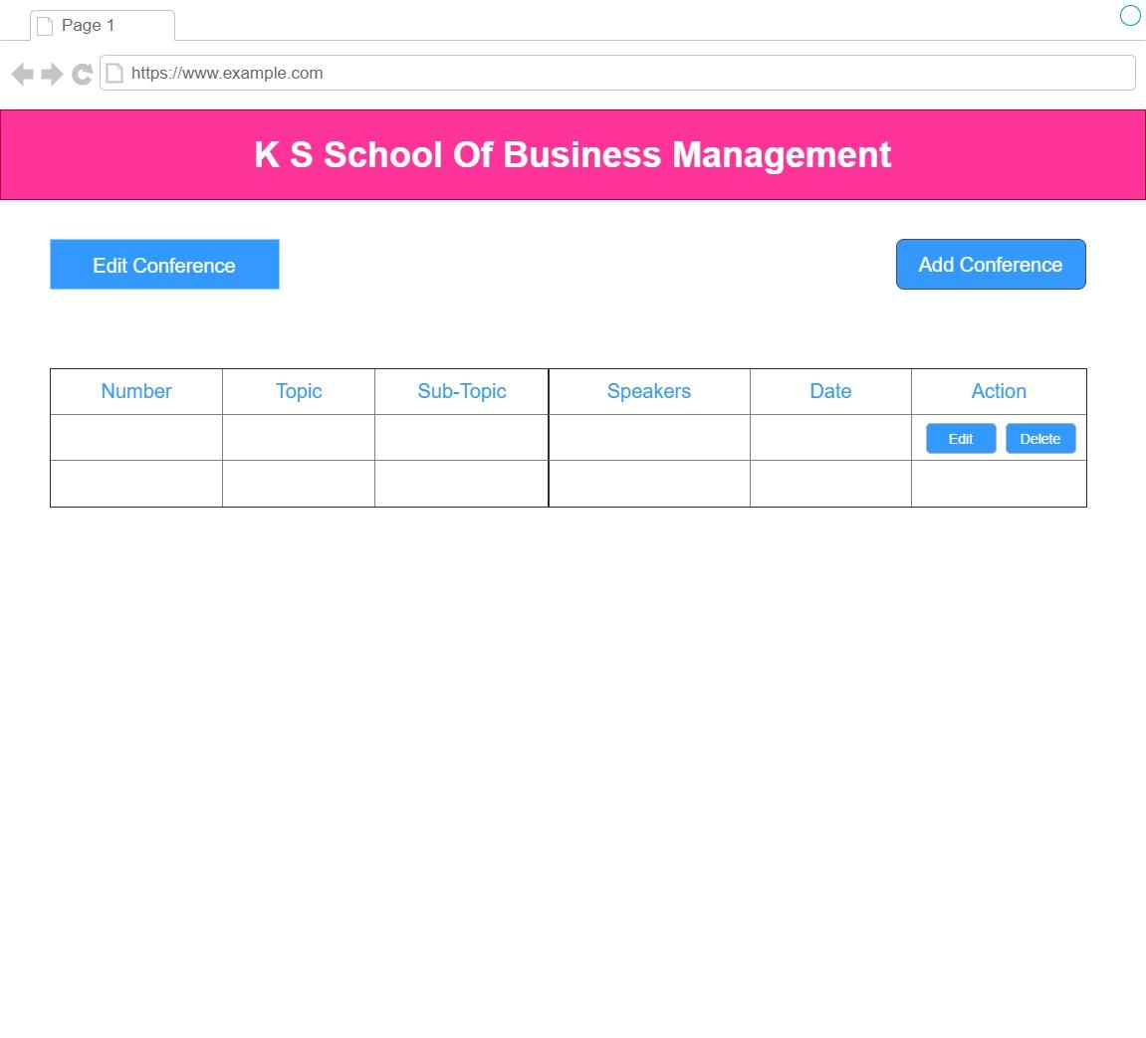

Description: Admin can Add/Update/Delete the conference details.

Edit Notice:

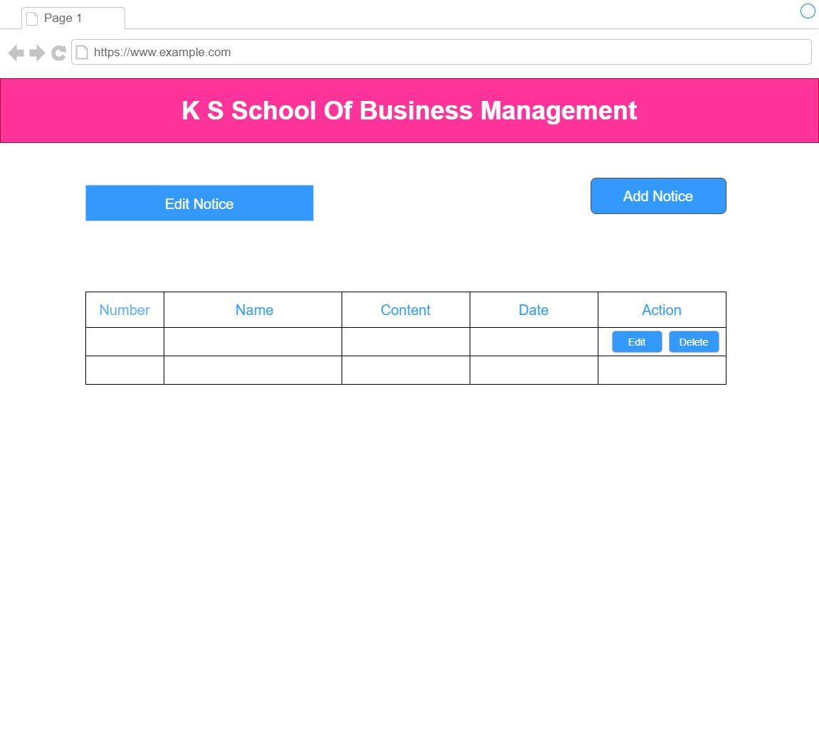

Description: Admin can Add/Update/Delete the notices.

View Participants:

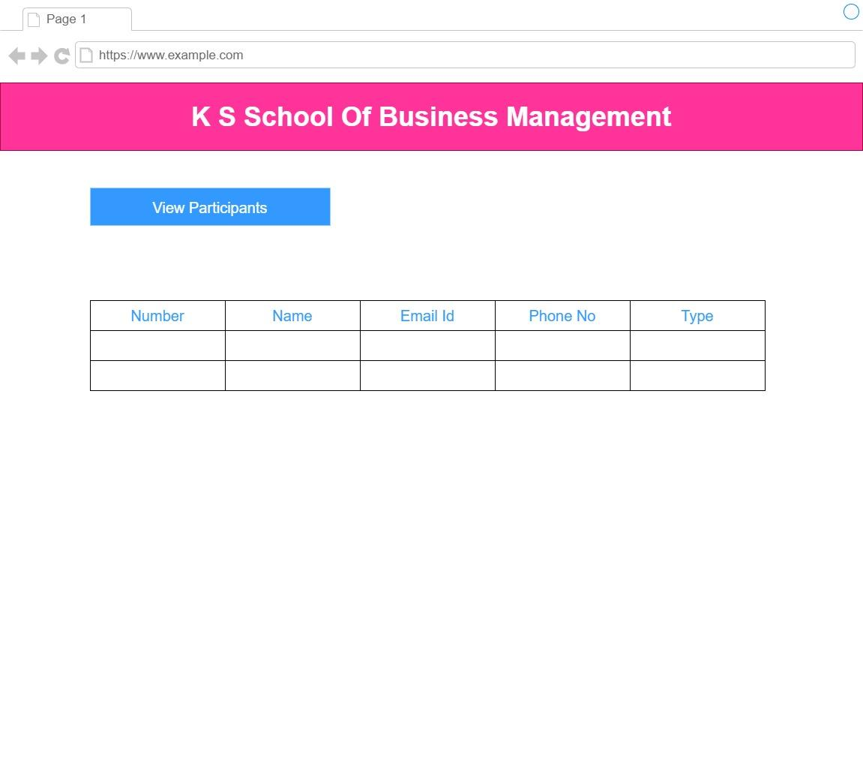

Description: Admin can view all participants.

View Researcher:

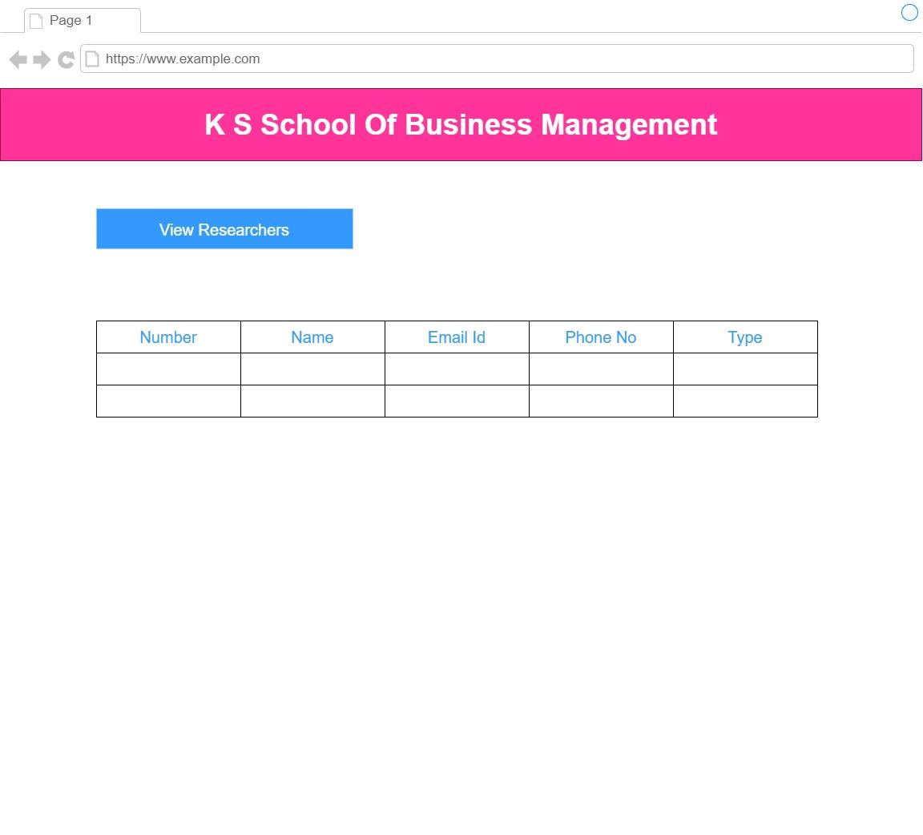

Description: Admin can view all researchers.

View reviewer:



Description: Admin can view all the reviewers.

View Feed Backs:

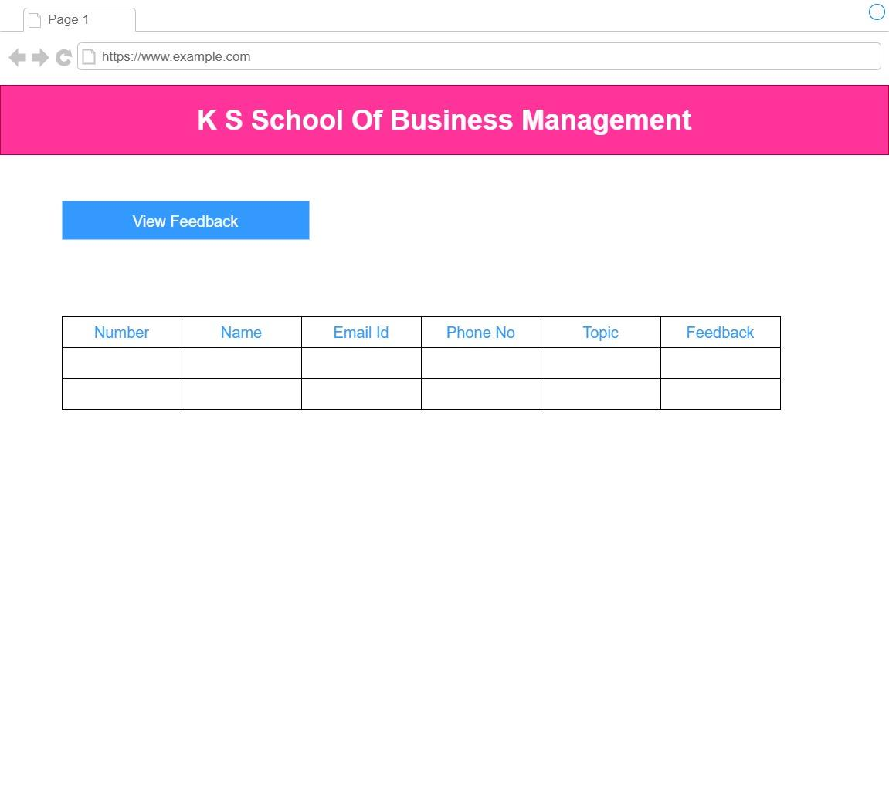

Description: Admin can view all the feedbacks.

View Submissions:

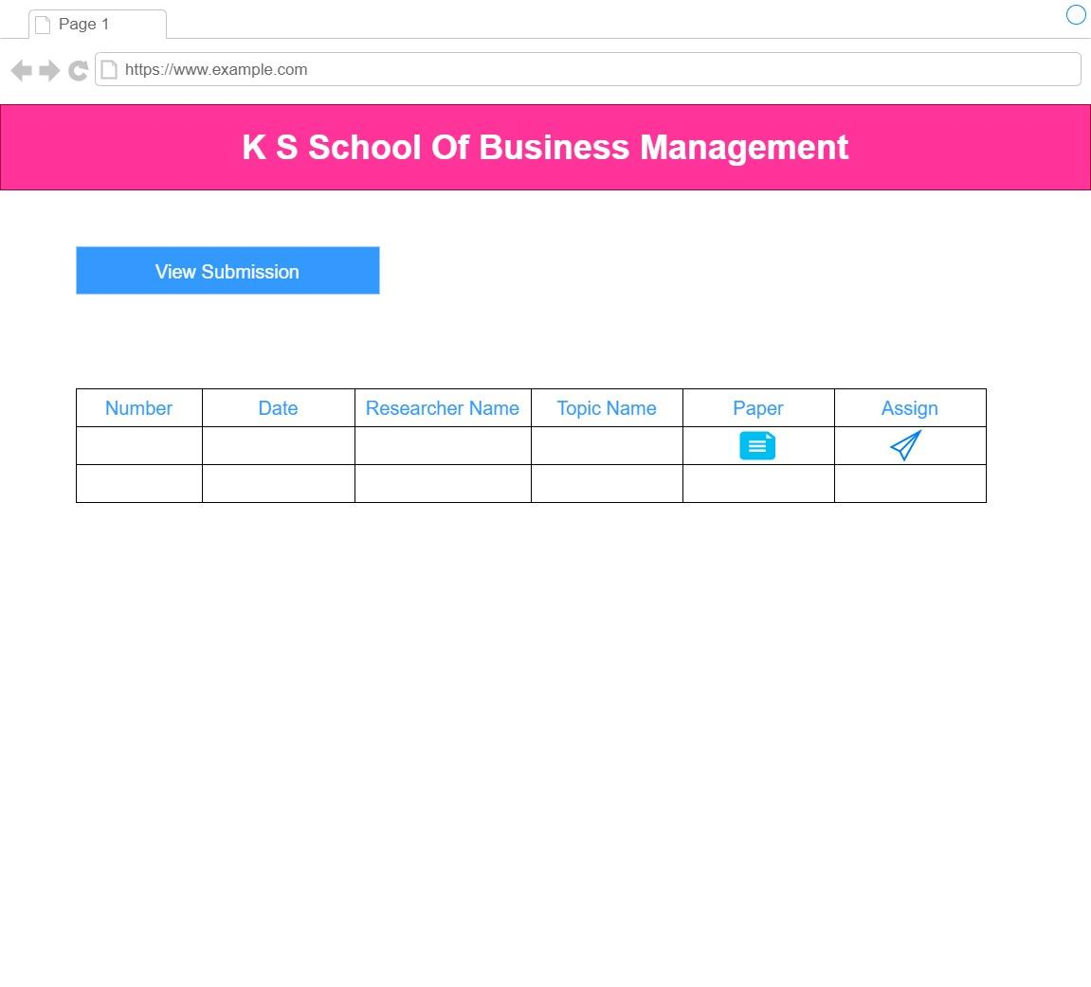

Description: Admin can view all the submissions of abstract and full paper and assign it to the reviewer.

View Reviews:

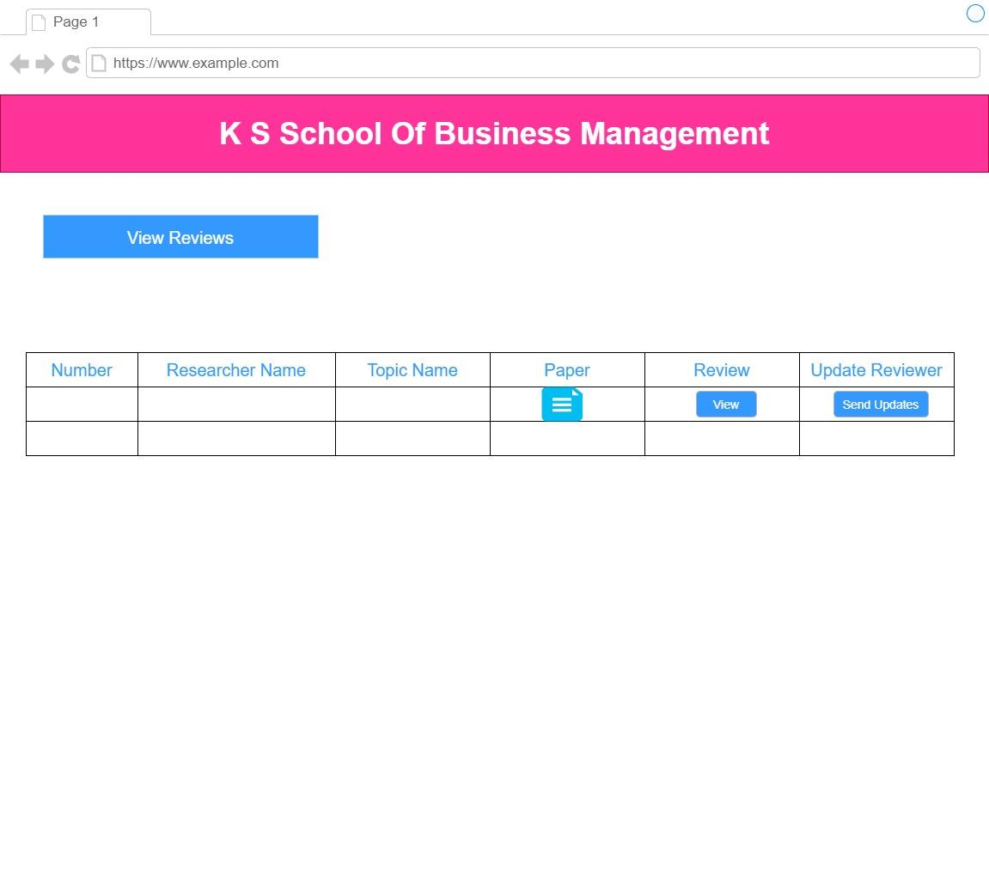

Description: Admin can view all the reviews of abstract and full paper and send updates.

View Status:

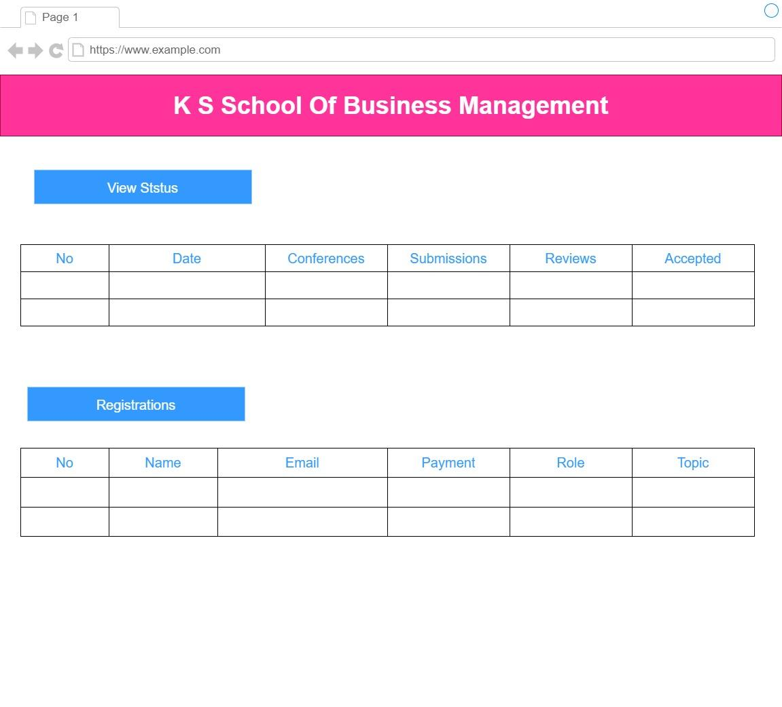

Description: Admin can view status of all conference regarding total submission, reviews, and accepted papers. Admin also view all the registrations.

Participant:

Home Page: 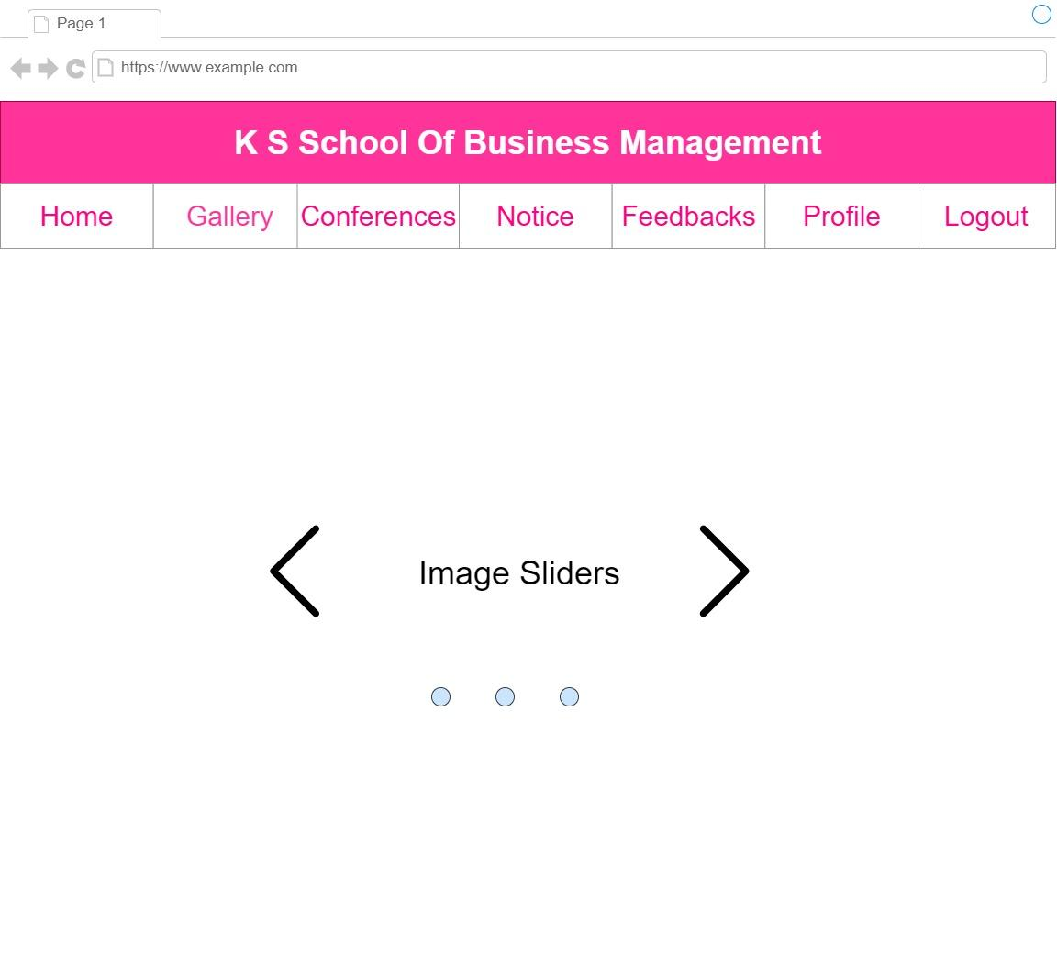

Description: Participant can view all the modules.

Participant Profile:

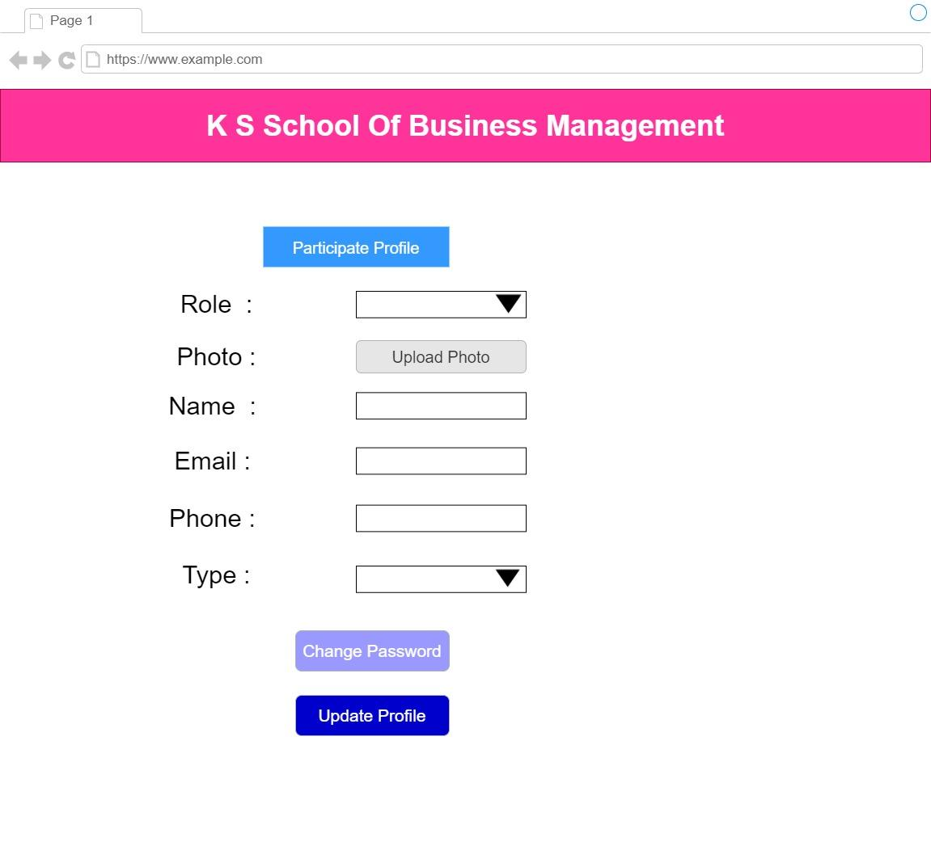

Description: Participant can edit their profile and change password.

Registration Form: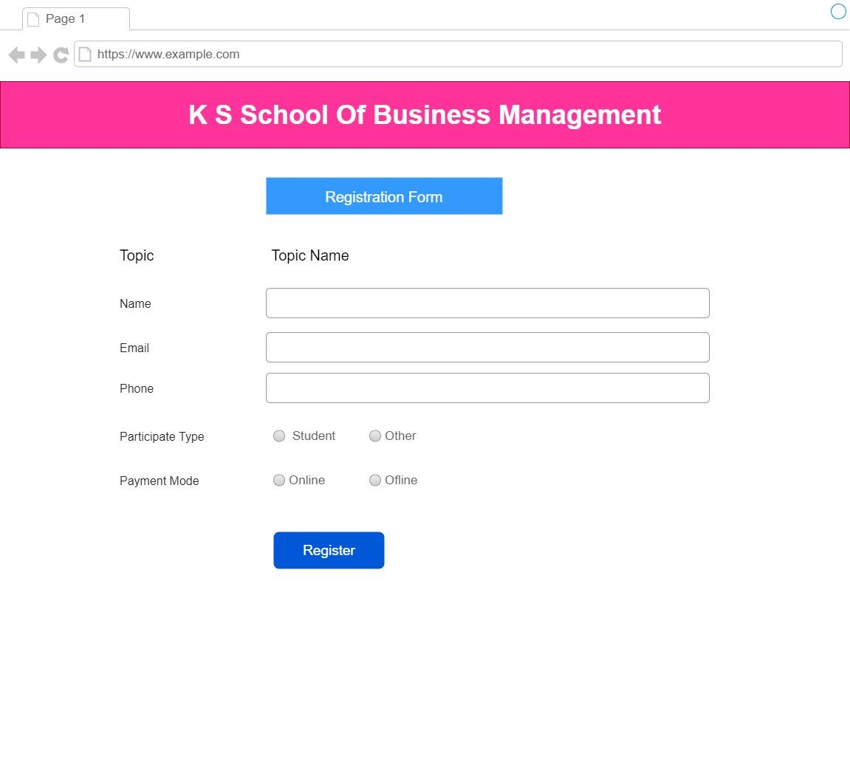

Description: Participant can register them self in conference.

View Conference: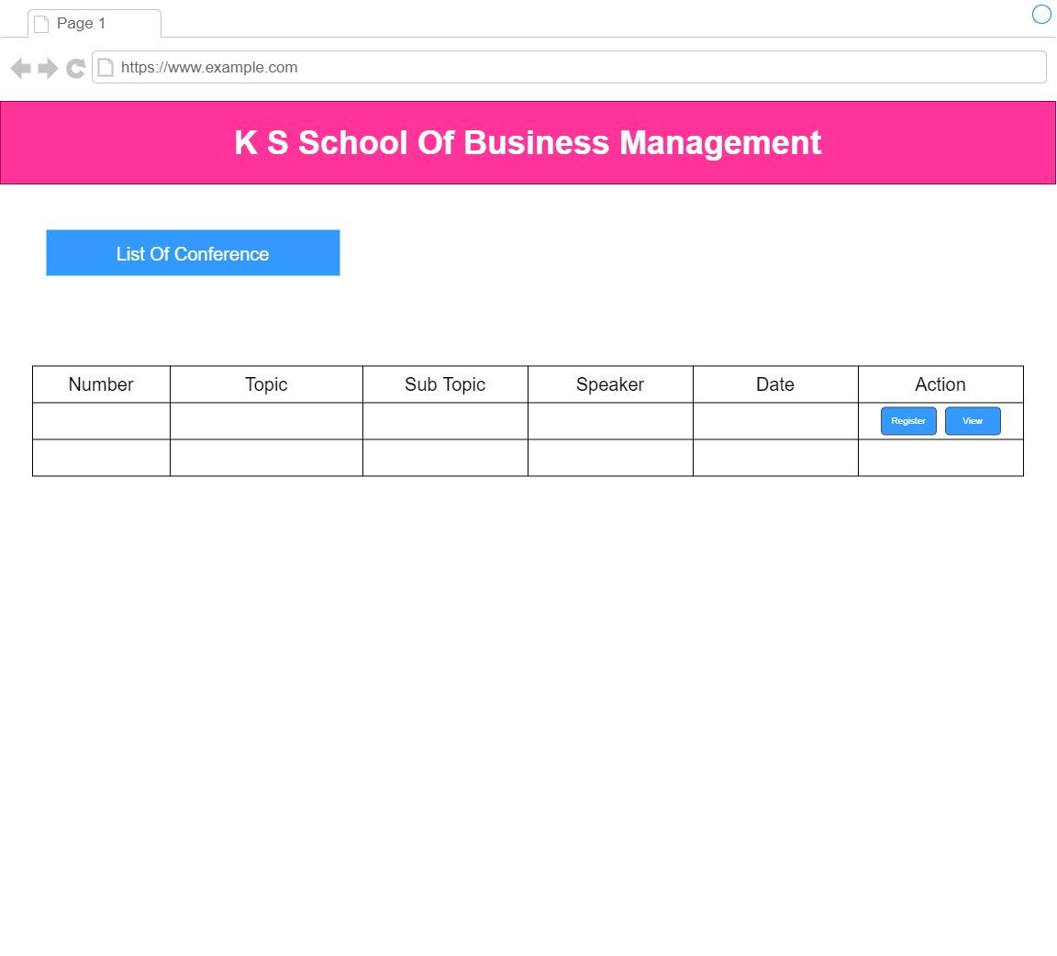

Description: Participant can view list of conference and its detail.

Researcher:

Home Page:

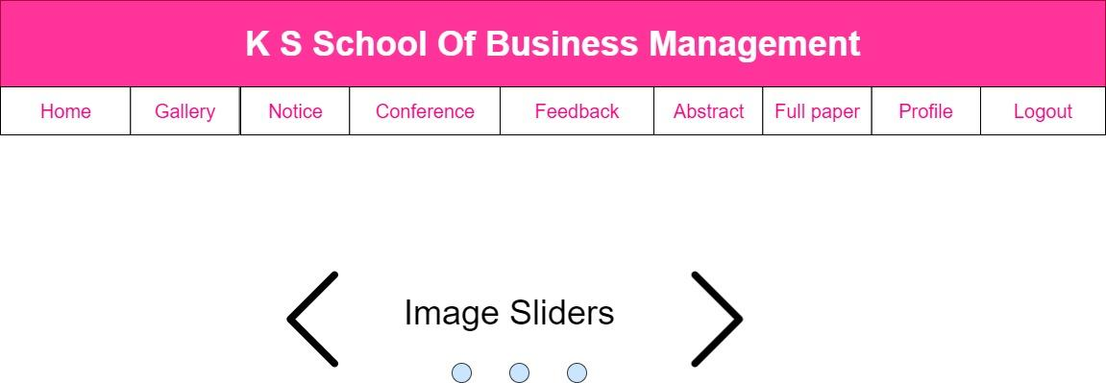

Description: Researcher can view all the modules.

Submit Abstract:

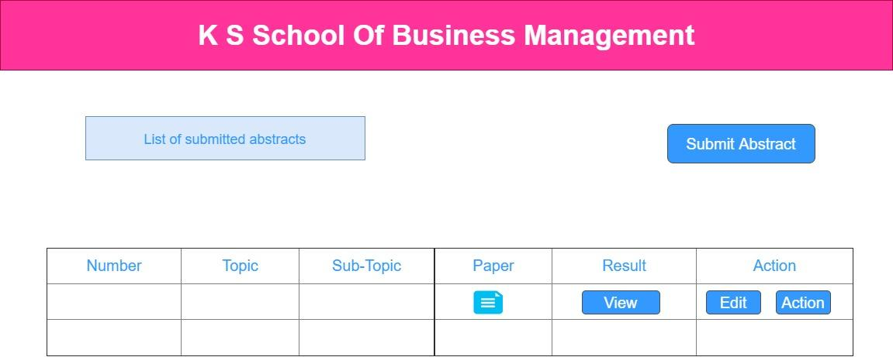

Delete

Description: Researcher can submit abstract and view list of his submitted abstract.

Submit Full Paper:

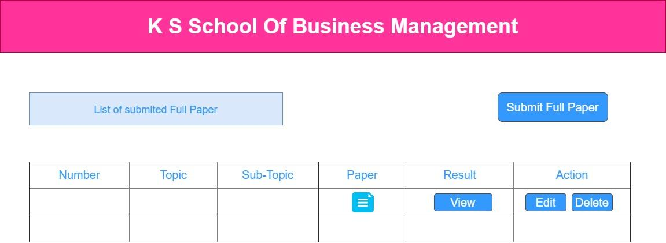

Description: Researcher can submit full paper and view list of submitted full paper.

Researcher Profile:

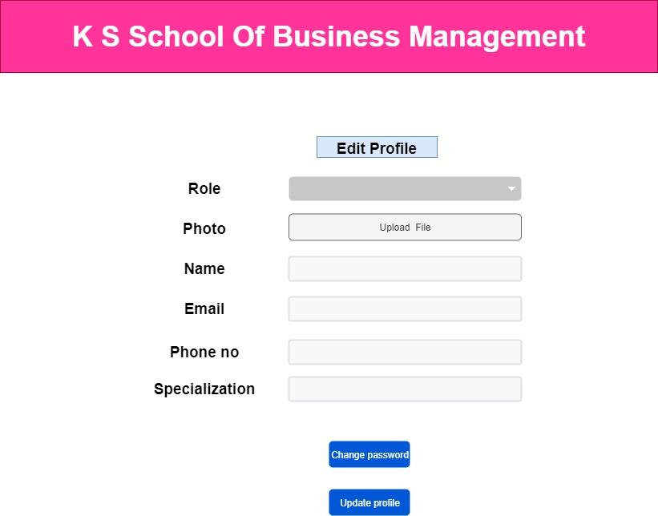

Description: Researcher can edit their profile and change password.

Reviewer:

Home Page:



Description: Reviewer can view all the modules.

Review Abstract:

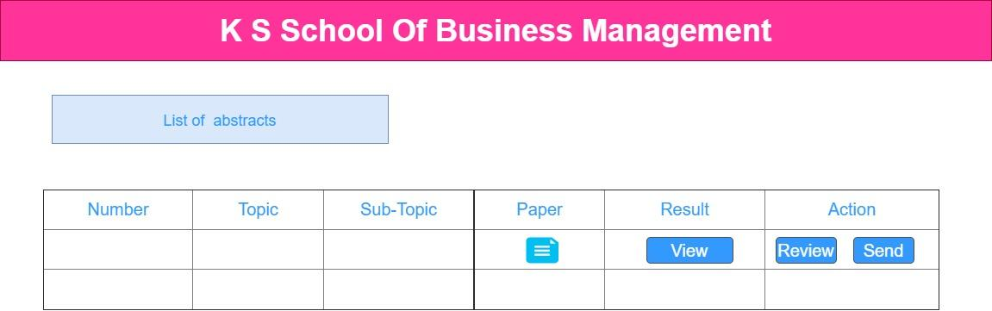

Description: Reviewer can view abstract and give review and send their reviews to the admin.

Review Full Paper:

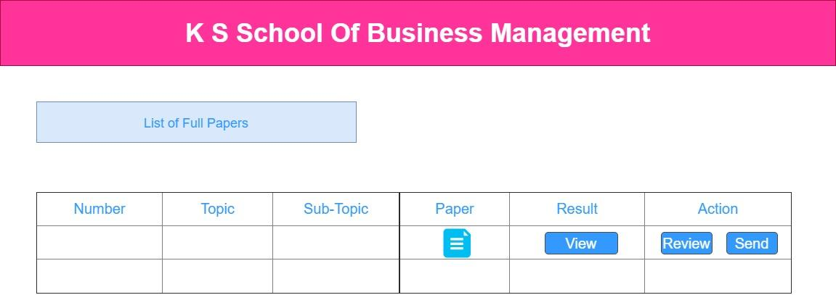

Description: Reviewer can view full paper and give review and send their reviews to the admin.

Reviewer Profile:



Description: Reviewer can edit their profile and change password.

4.5 System Navigation: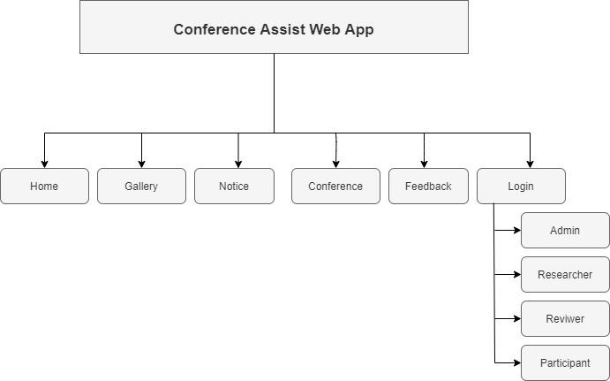

SUMMARY

Assumption:

* We assume that all the features that we are trying to provide for them to make their all the process of conference easy and faster will be accomplished by using this system.
* Users must have proper tools to run this system.
* Users will be able to register themselves.
* User must have basic knowledge about common browsing and surfing.
* User must be bit knowledgeable about English language.

Limitations:

* The limitation of this application is need for high speed internet data to do work on it.
* This web application does not provide offline mode.
* Some of the core features of the system are quiet designed for higher educated people (Researcher, Reviewer) so these features becomes less productive for some people.

Conclusion:

* The main purpose of this application is to satisfy every user and also give user friendly environment for the users.
* This application mainly helps organization to manage all the process, researcher to submit their work, reviewer to give reviews and participant to register according to their requirements with much more easier process.
* We know we might have made some mistakes knowingly or unknowingly. But all the suggestions regarding to this system are always welcome.

Future Scope:

* In future main efforts will be making this application more user friendly through their feedbacks.
* In future there are changes to add the feature of video conference.

Bibliography:

* For protocol & prospective purpose:

<https://www.easychair.com>/

<https://www.OpenConf.com/>

* For diagrams & chart illustration:

<https://draw.io/>

* For Theoretical Guidance:

*Software engineering: A Practitioner’s Approach*,

***Roger S. Pressman***, Seventh Edition, 2010.

*Fundamentals of Software Engineering,*

***Rajib Mall***, Fourth Edition, 2008.

*System Analysis & Design,*

***Kenneth E. Kendell, Julie E. Kendell***, Ninth Edition, 2015.